ed together, can make your tech portfolio stand out. And as an added bonus, I even included real-life samples of these tips in action.

27 THINGS TO PUT ON YOUR DEV / DESIGN PORTFOLIO

1. A CUSTOM LOGO AND TAGLINE
If you’re more in the design space, show off your skills by creating your own awesome logo.
Then, create a strong tagline underneath. This can quickly tell visitors who you are and what you can offer them. Making your message clear off the bat is important.

REAL-LIFE EXAMPLE:
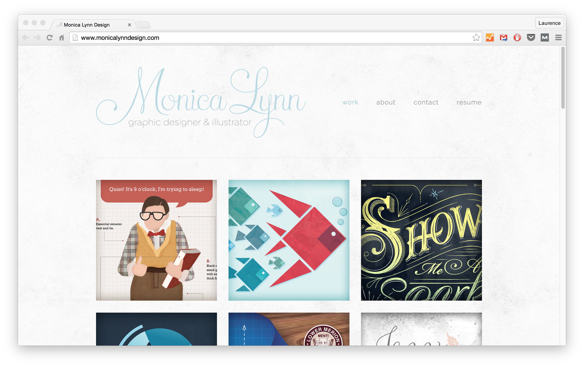Source: Monica Lynn
27 things you can add to your online portfolio, even if you're starting out.
CLICK TO TWEET

2. A KILLER SITE DESIGN
Having a clear and concise online portfolio/resume design is important, no matter what. But if you’re more into design than development, it becomes even more significant.
However, the most important thing in a site design is usability. Can a person come to this site and understand the message? Can they easily navigate the site without becoming confused?
If the answer is “no,” you need to rethink your design decisions.
In the example below, SEO consultant Gary Le Masson makes his portfolio/resume look like Google search results. The site is clever. And it is perfect for the clients he going after: people who want to rank high in Google search results.

REAL-LIFE EXAMPLE:
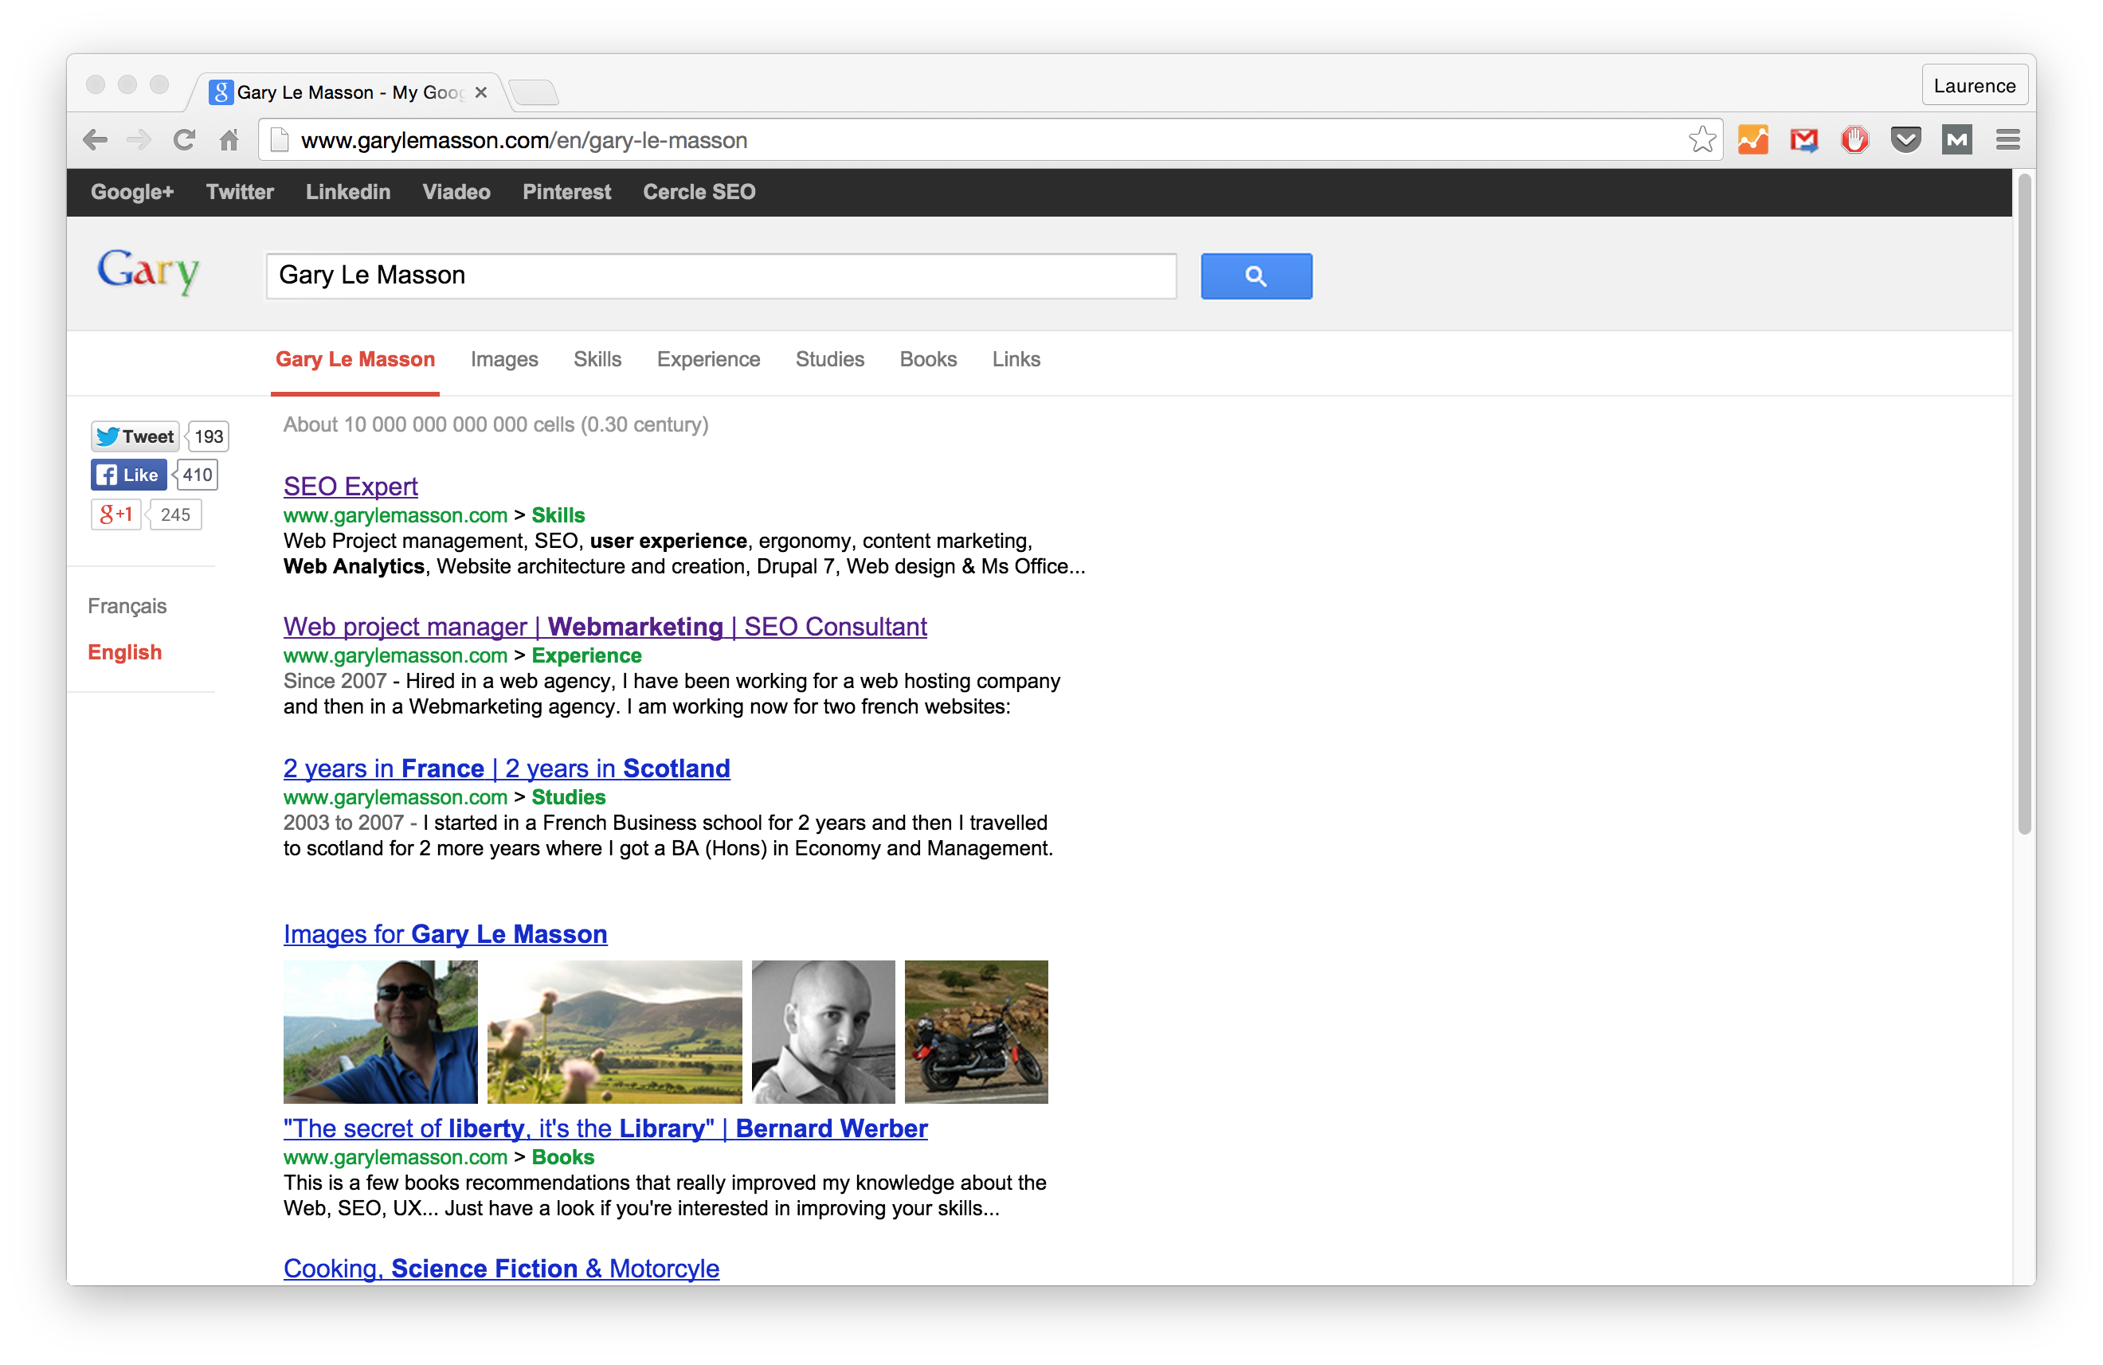Source: Gary Le Masson

3. RELEVANT SKILLS
The more skills you have, the better—but only if you’ll actually use them in the kind of work you want.
These skills could have been picked up in online courses or from previous positions. Even things you learned while volunteering or in school. There’s no wrong way to gain a skill.
As long as they’re relevant to the jobs you want to start landing: that’s what’s important.
When adding skills to your portfolio, relevancy to jobs you *want* is what's important.
CLICK TO TWEET

REAL-LIFE EXAMPLE:
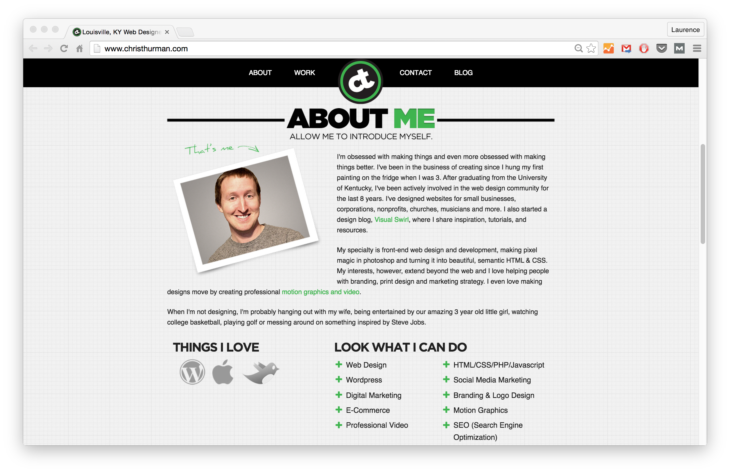Source: Chris Thurman

4. RELEVANT EDUCATION AND CERTIFICATES
This includes courses (online or offline) or even college classes. Some online learning platforms even integrate with your LinkedIn, making it easy to add certificates from completed courses.

REAL-LIFE EXAMPLE:
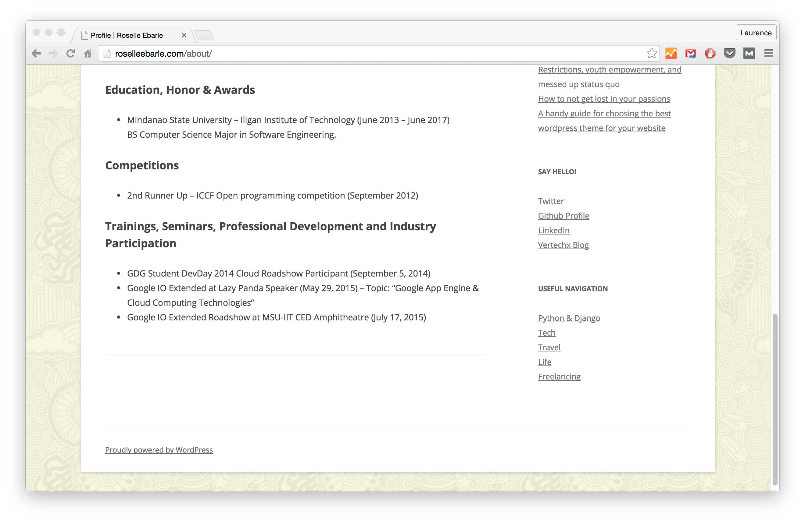Source: Roselle Ebarle
Struggling trying to figure out *what* you should say on your portfolio? Here are 27 ideas.
CLICK TO TWEET

5. ANY PREVIOUS JOBS THAT HAVE SOME TRANSFERABLE EXPERIENCE
Ever had a job where you used transferable skills?
Here’s a personal example:
While working at Education First (EF) years ago as an “Activities Intern,” I helped create a blog of upcoming student activities. Sure, I used a theme and a free platform, like WordPress.com, to host it. But that had relevance later on, so I added it to my experience section in the beginning.
However, nix all your unrelated positions, like your nanny job. (Unless you built a website for that role!)

REAL-LIFE EXPERIENCE:
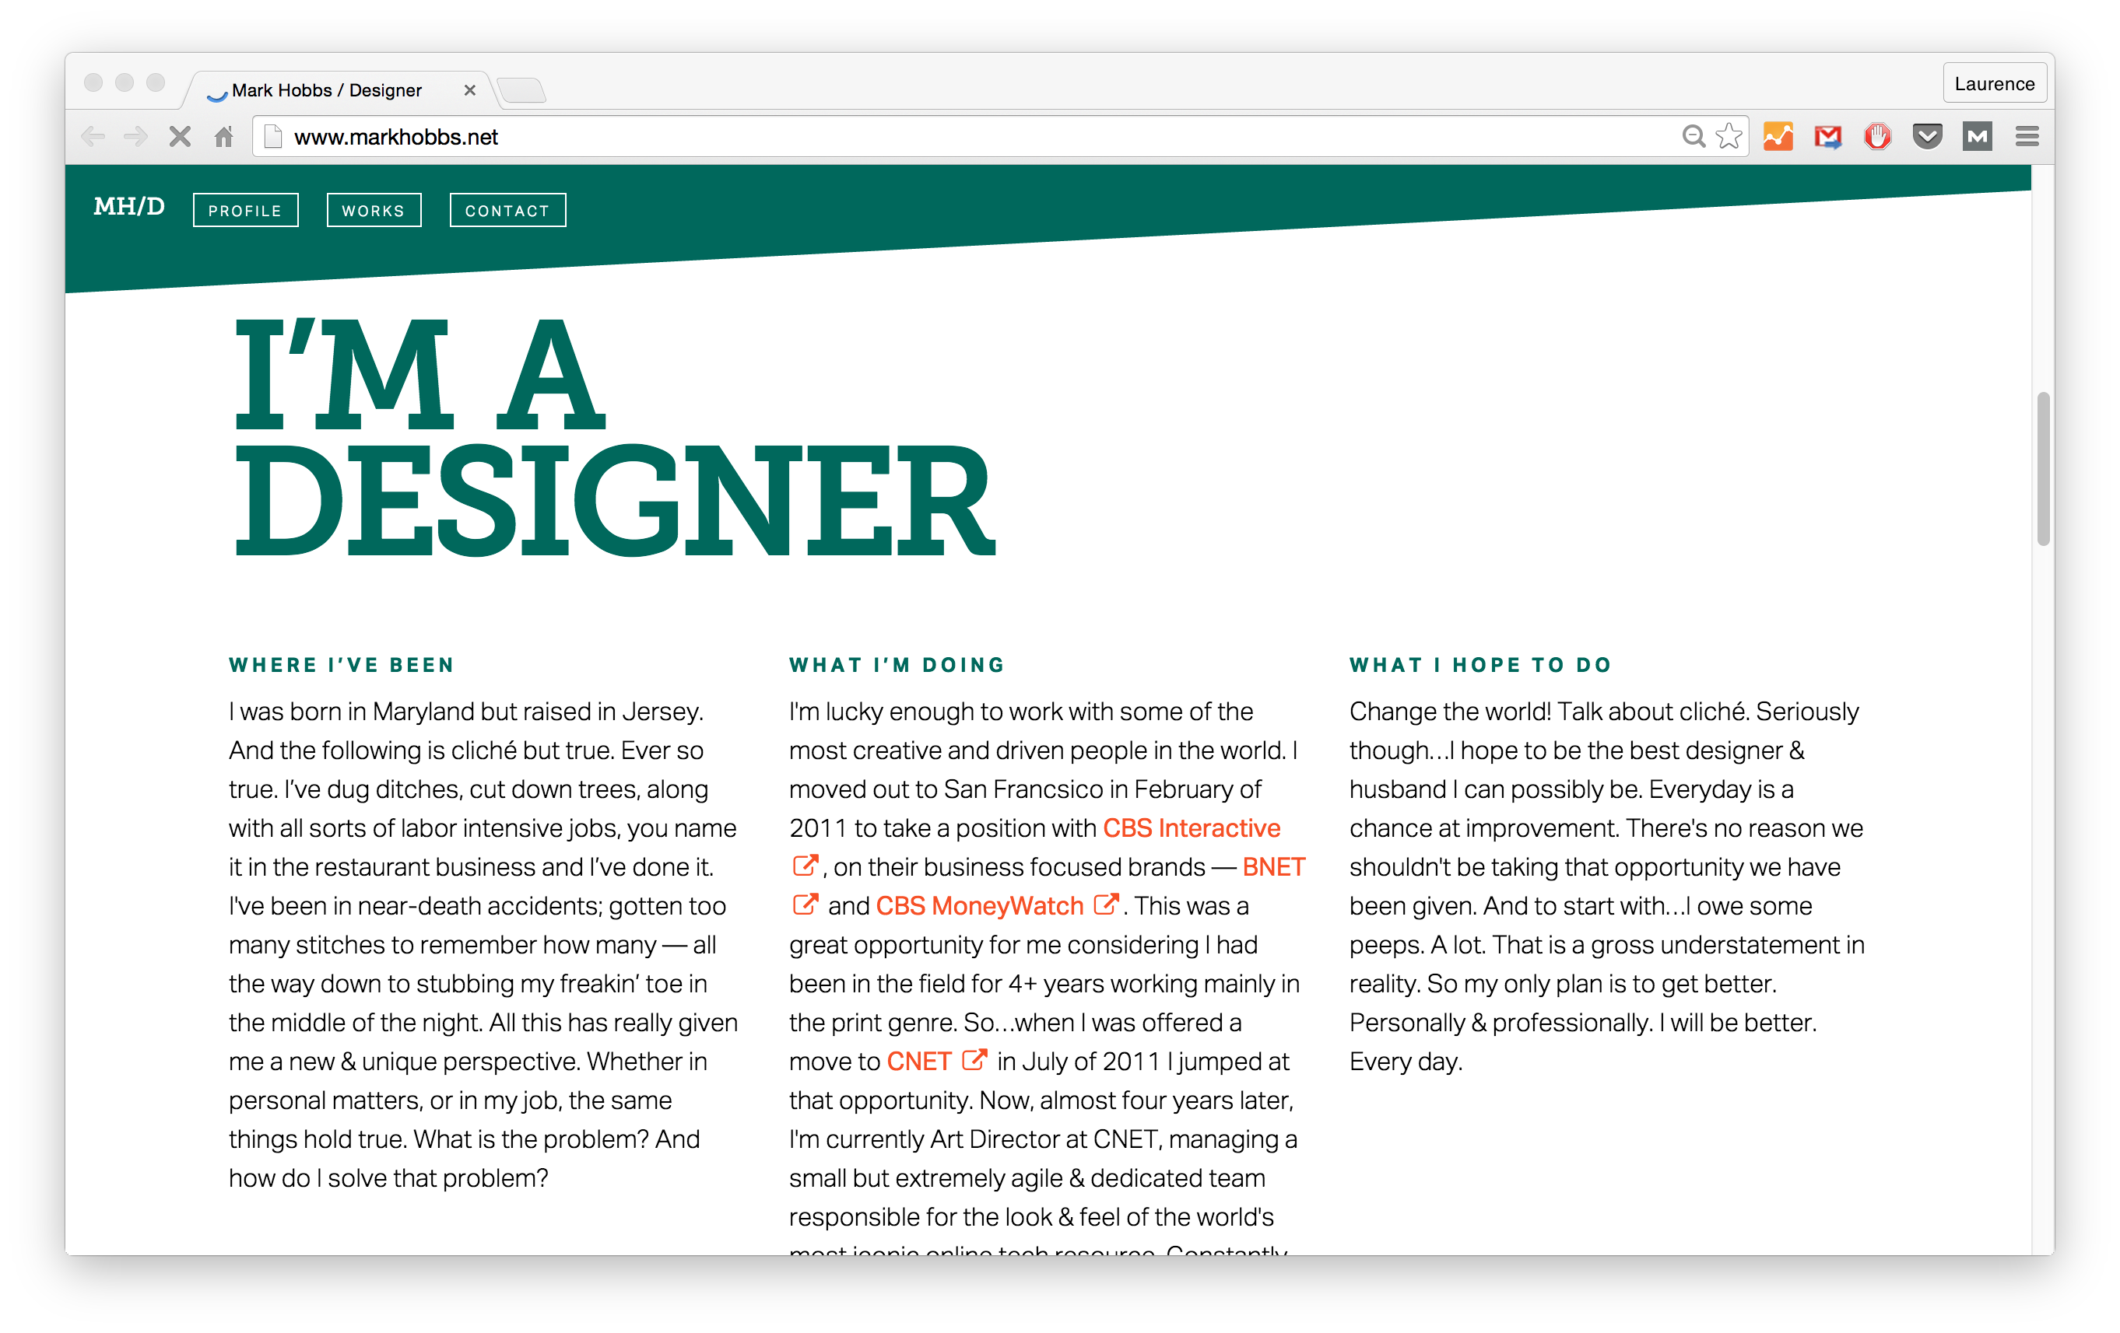Source: Mark Hobbs

6. DOWNLOADABLE RESUME
People still use hard-copy resumes today—even though it may seem like a rarity. This is especially true in more traditional workplaces, with human resource divisions.
Because of this, you should make it simple for potential employers to download a copy of your resume and print it out if they want to.

REAL-LIFE EXAMPLE:
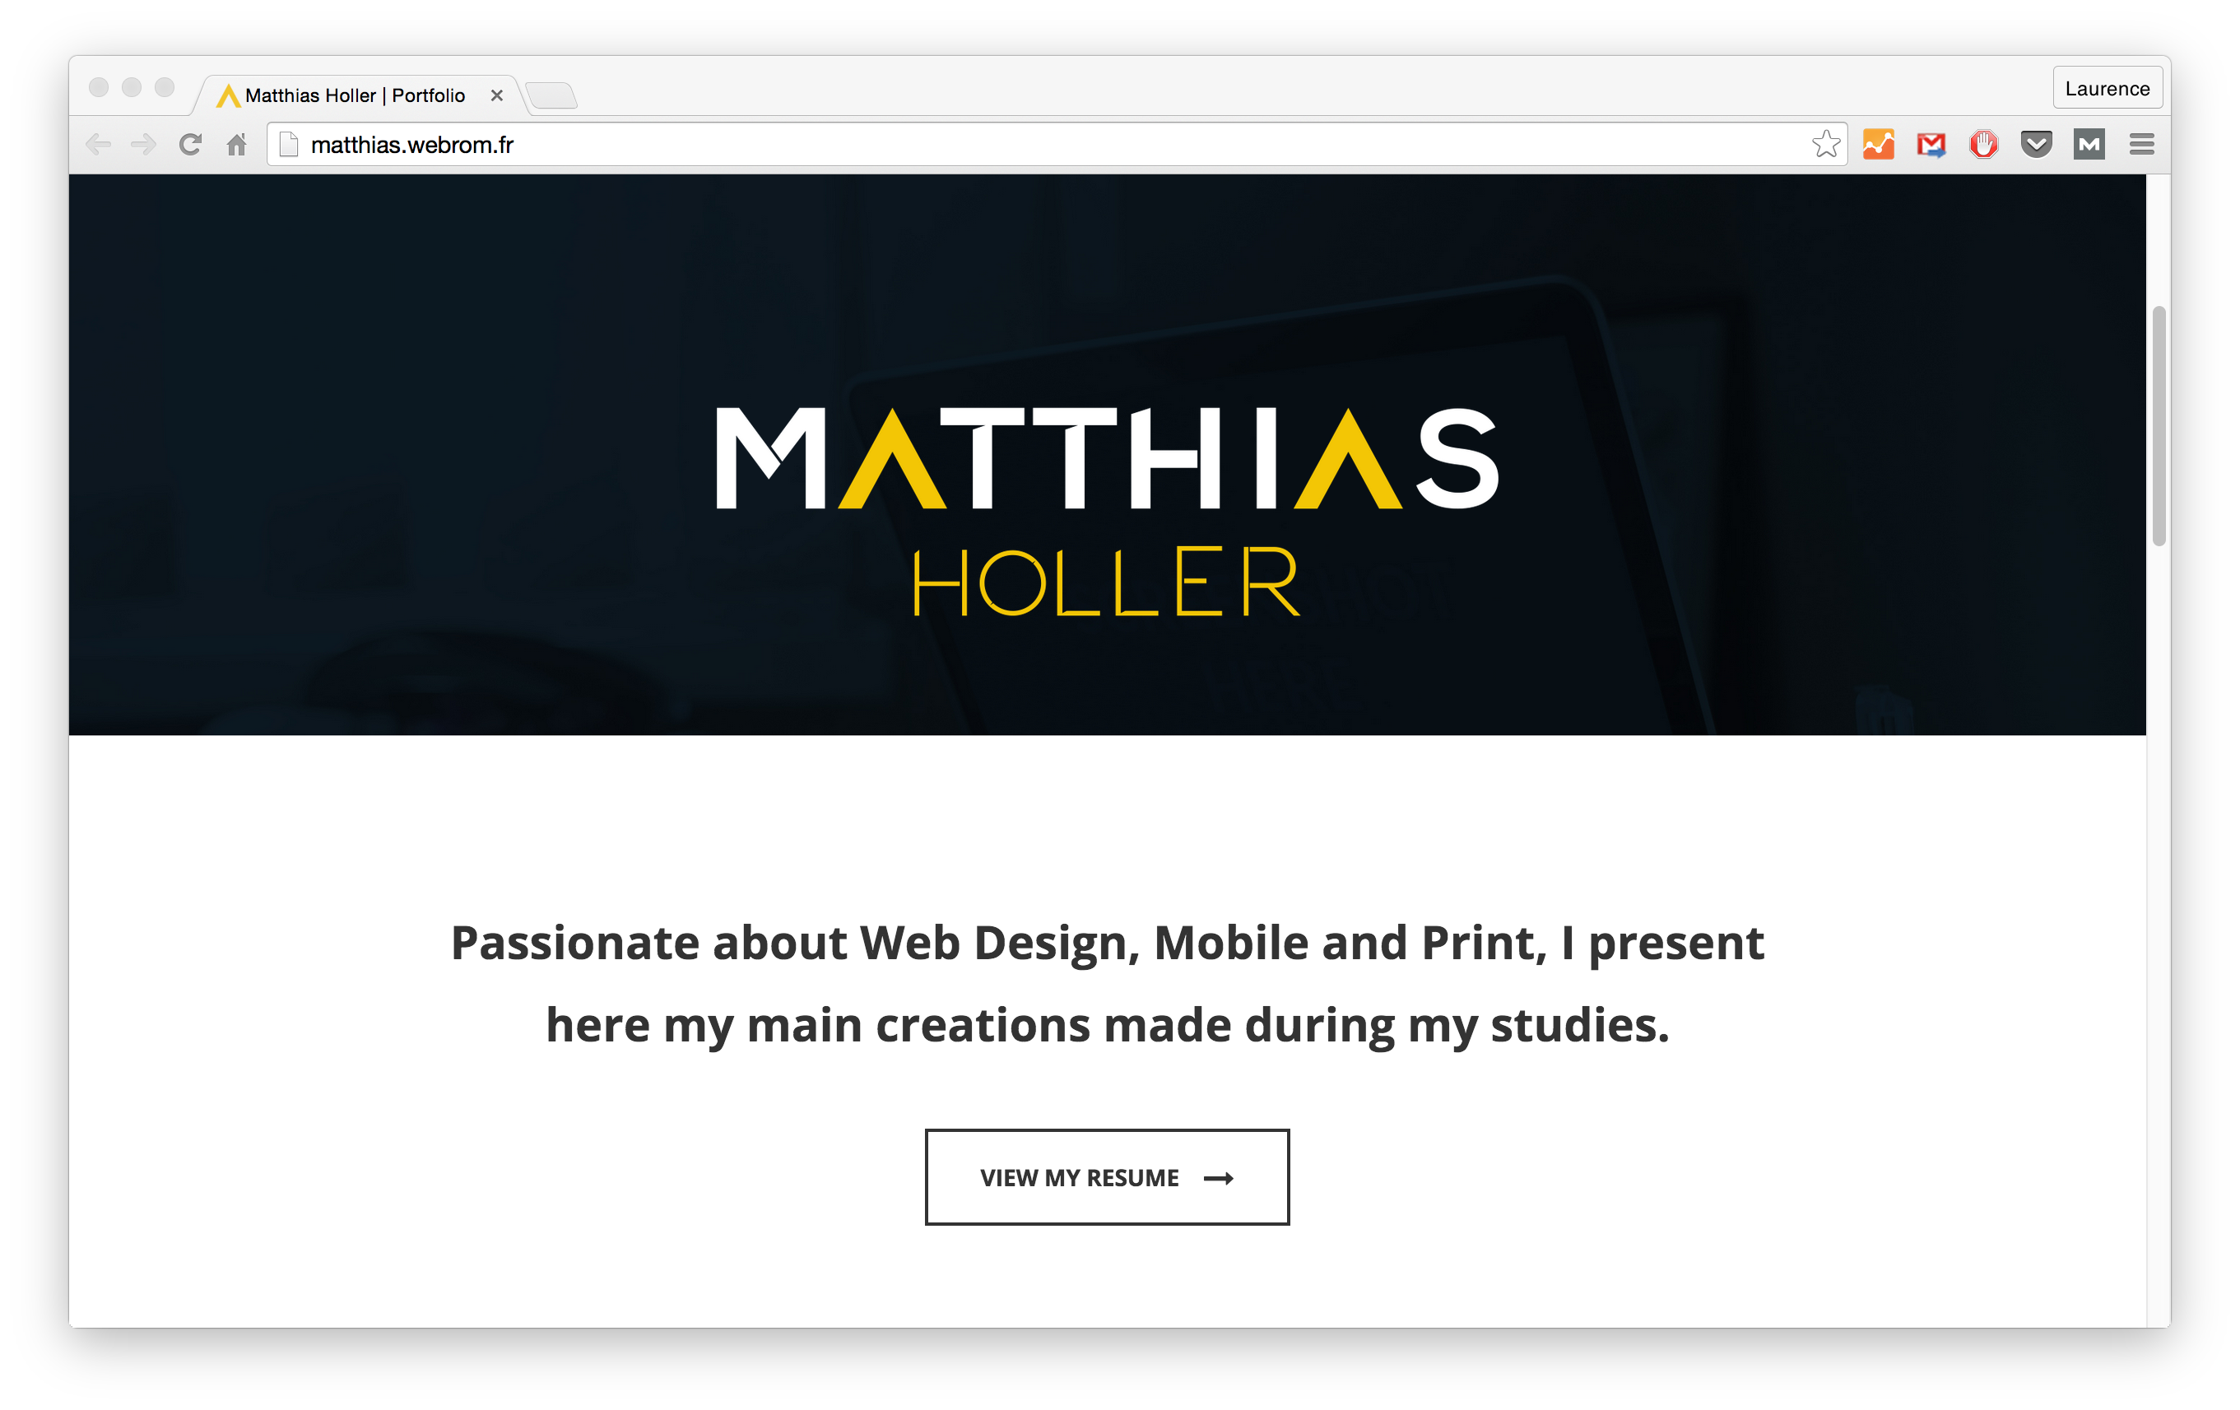
Source: Matthias Holler

7. A BIO OR ABOUT PAGE (TELL YOUR STORY!)
Let your personality come through. It’s *your* portfolio, after all!
Plus, it has been shown that stories are more engaging than just listing out information.
When creating a portfolio online, tell stories. They're much more engaging than facts.
CLICK TO TWEET
Not much of a wordsmith? Don’t worry. There other ways to create a bio or “about” page that makes you stand out. (See the example below.)
Or you can always find a writer/editor on Upwork to lend a hand.

REAL-LIFE EXAMPLE:
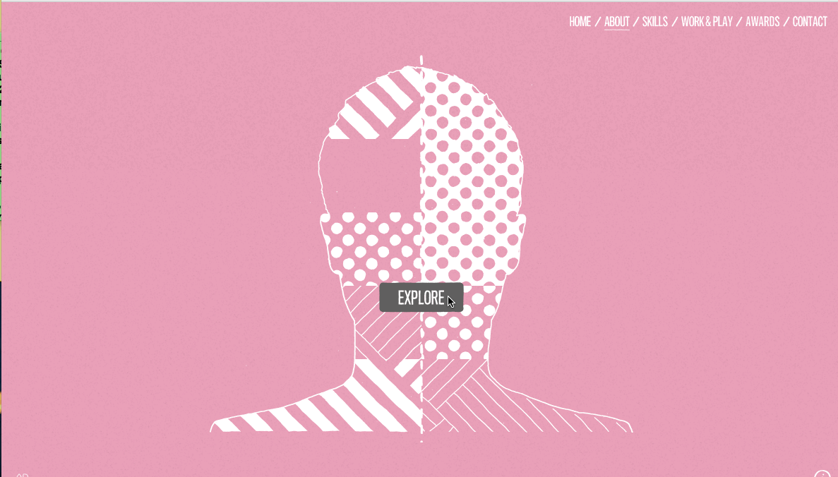
Source: Adam Hartwig

8. A PHOTO

JOIN THE FREE PORTFOLIO COURSE
Sign up below for my *free* course on how to build a portfolio site as a web developer/designer.
ENROLL NOW!Don't worry. I'll never, ever spam you!
People trust brands (and people) when they can put a “face” to them. It doesn’t have to be a gray-background headshot with a suit and tie, but keep the photo professional. This means no obvious selfies and an outfit that is safe for work, not the nightclub.
Not sure which photo to use? Look to the Buffer blog, where they recently put together an entire article about great profile photos.
Or you can always use it as an opportunity to show off your personality/interests, like Kendra does below.

REAL-LIFE EXAMPLE:
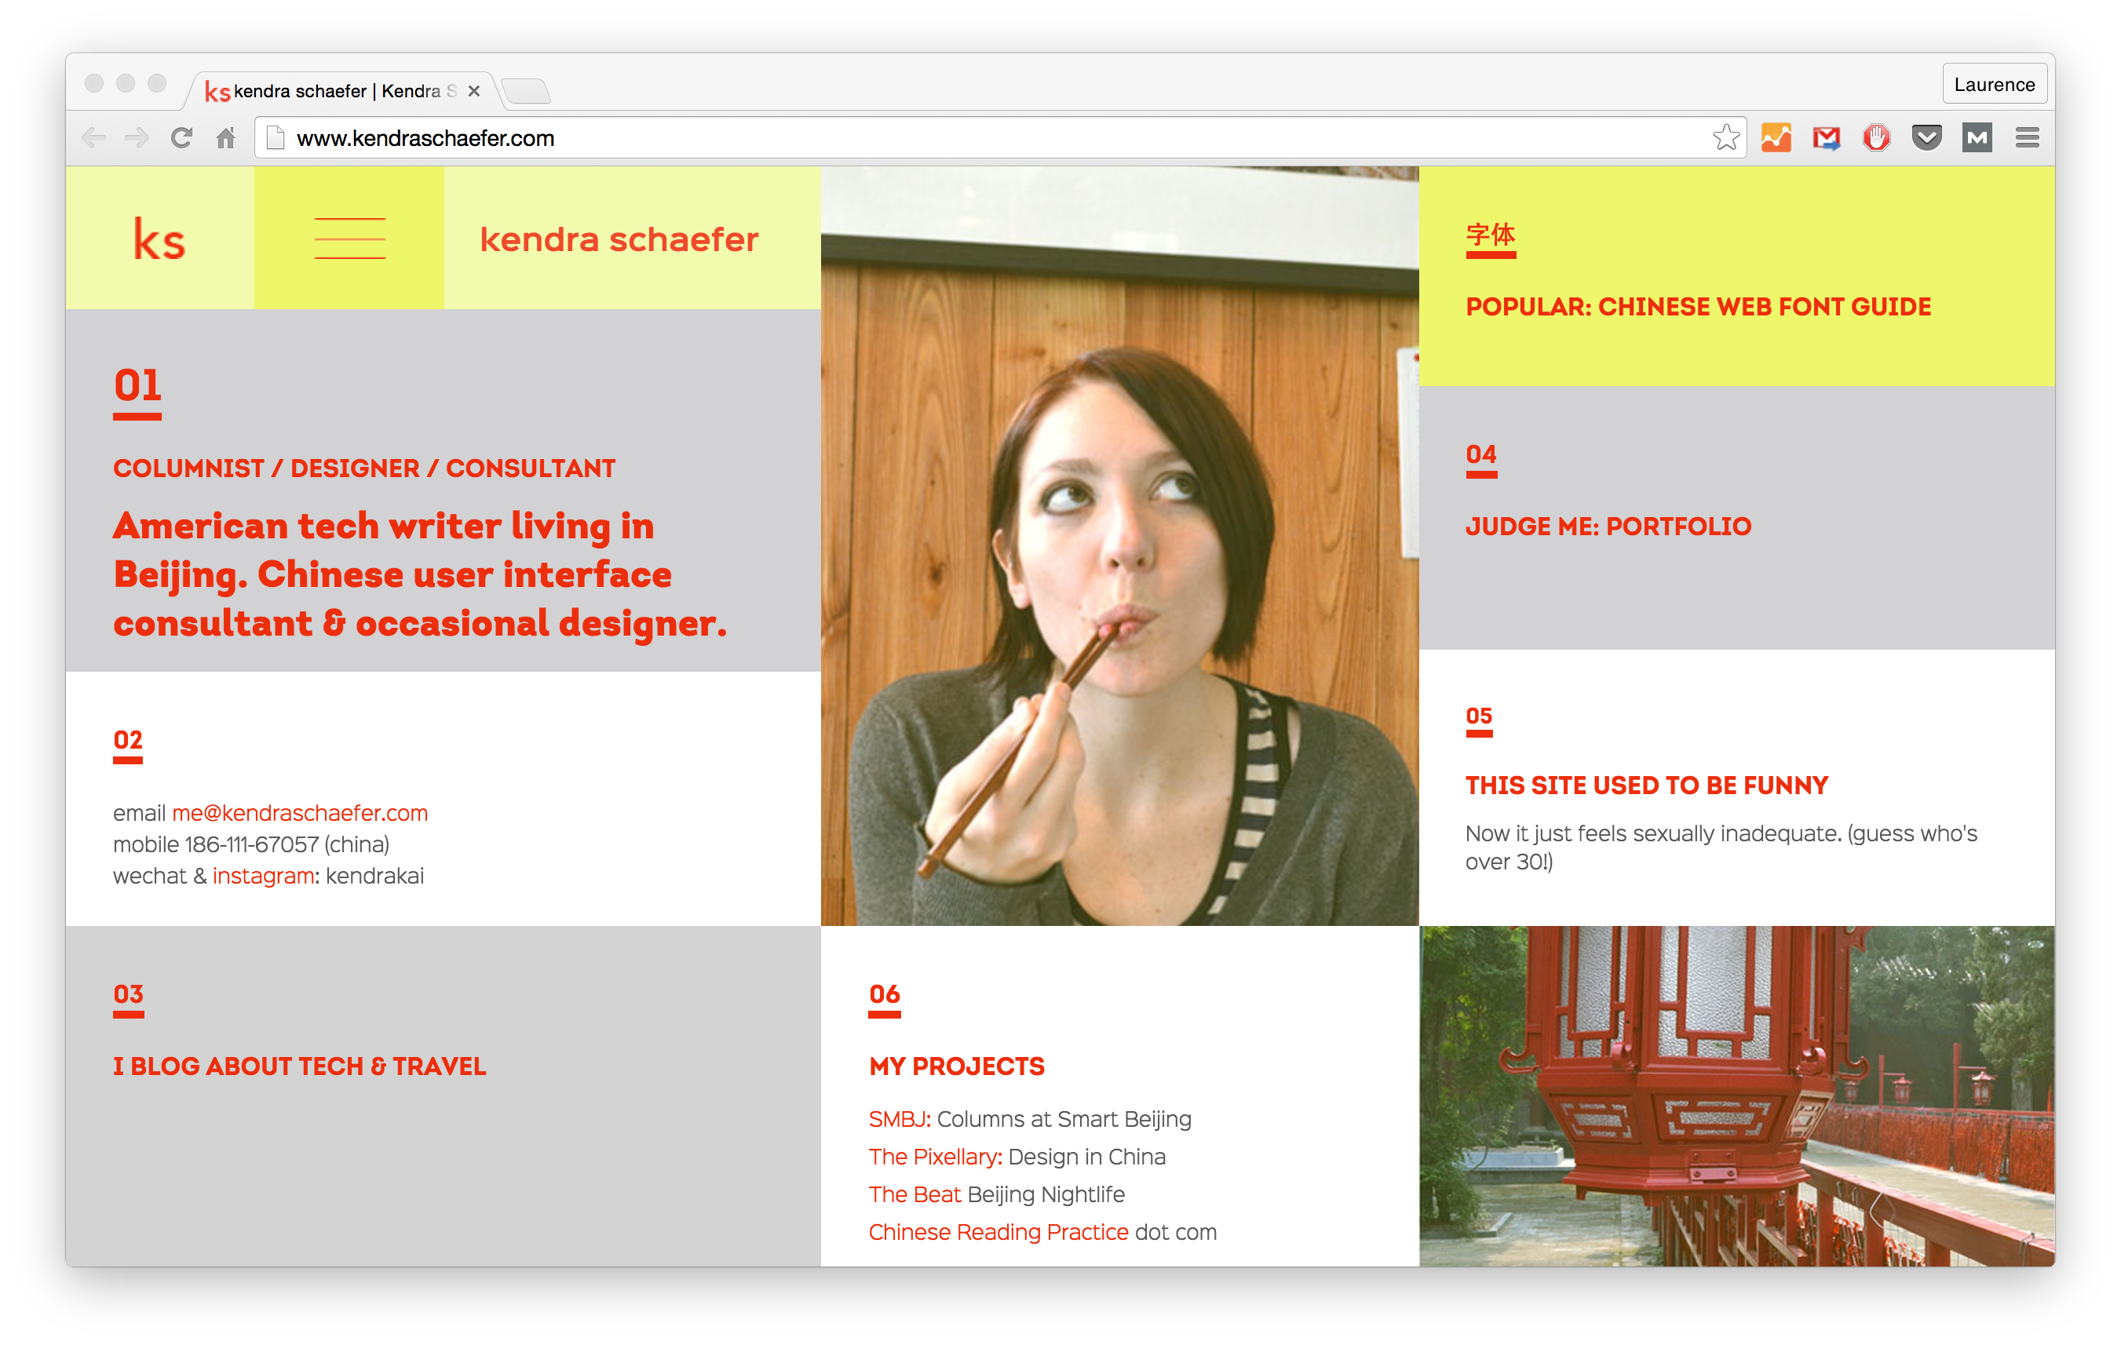 Source: Kendra Schaefer

9. VISIBLE CONTACT INFORMATION
Don’t make it an obstacle course for potential clients or employers to find your email address or phone number. Unless, of course, you don’t want people contacting you.
Portfolio pro tip: make it easy for potential employers/clients to find your contact info.
CLICK TO TWEET
The ideal way to reach you (probably email) should be easy to find. Like the example below, with an email address right at the top. You could include a telephone number if you’re comfortable giving that out to the world; however, nowadays an email address alone is sufficient.

REAL-LIFE EXAMPLE:
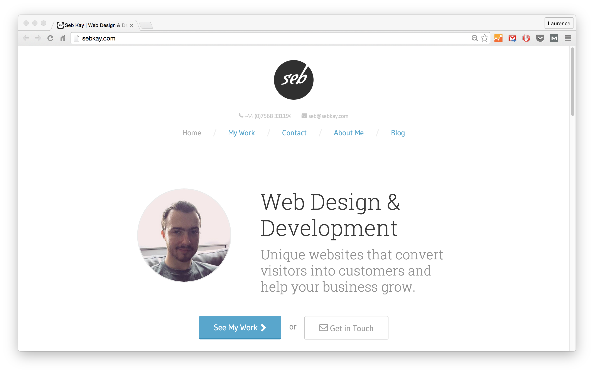Source: Seb Kay

10. SOCIAL MEDIA ACCOUNTS (IF RELEVANT)
If you have any active (and relevant) social media accounts, include them!
A LinkedIn profile is a must for everyone—freelancer or full-time. It acts like a resume in itself. But more than that job recruiters go to LinkedIn to search for talent—another *huge* reason to be on it.
Also consider maintaining a presence on industry-specific social media accounts:
- Github for developers
- Dribbble or Behance for designers
Like with all of these, relevancy is key. Don’t include your Instagram filled with #OOTD…well, unless you want a job in the fashion industry!
Feel free to include your Twitter, Tumblr, etc., too. As long as it is relevant and you don’t mind potential employers/clients seeing it.
A few basic social media ground rules:
- Don’t complain about your current job/boss/coworkers.
- Avoid posting pictures getting #whitegirlwasted at the club on a Tuesday.
- Stay away from insults and #drama.
These rules apply even if you choose not to include your social media accounts on your portfolio or resume.
Always be prepared for clients/employers to look you up on Google. (I can almost 90% promise that they will.)

REAL-LIFE EXAMPLE:
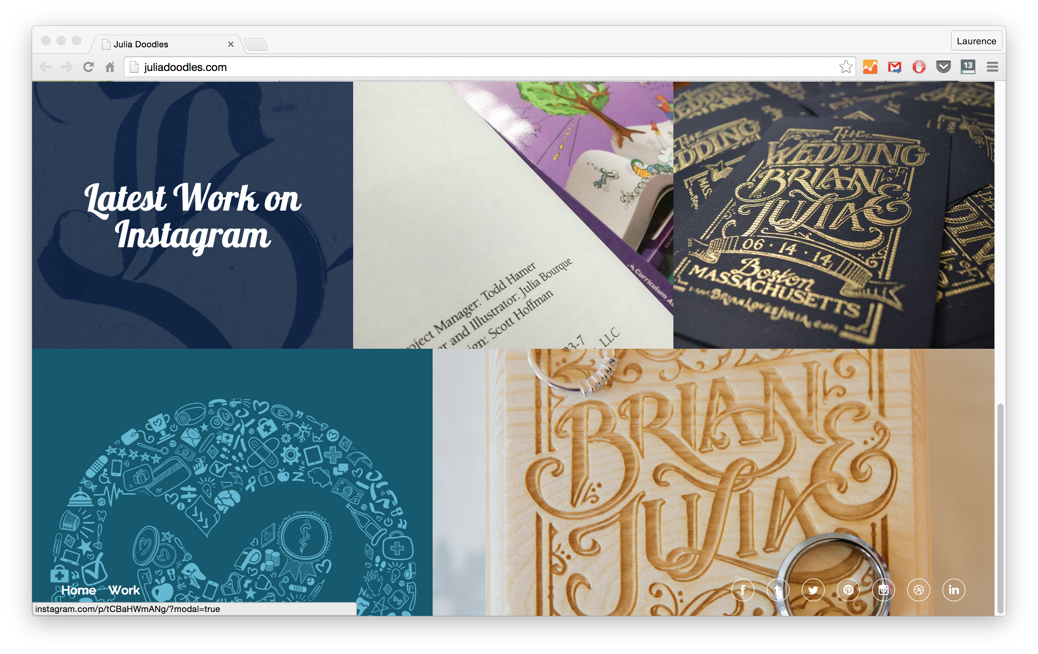Source: Julia Doodles

11. YOUR SPECIALTY (AKA SERVICES YOU OFFER)
Make clear what you do and/or what you specialize in, since dev/design positions can vary so much. If you create WordPress websites for small businesses, say that. If you’re passionate about Ruby on Rails, let your clients know.
Plus, making your specialties crystal clear helps screen potential clients. It decreases queries from those needing help with work you have no interest in, and gives you more legitimacy in the eyes of the clients you want.

REAL-LIFE EXAMPLE:
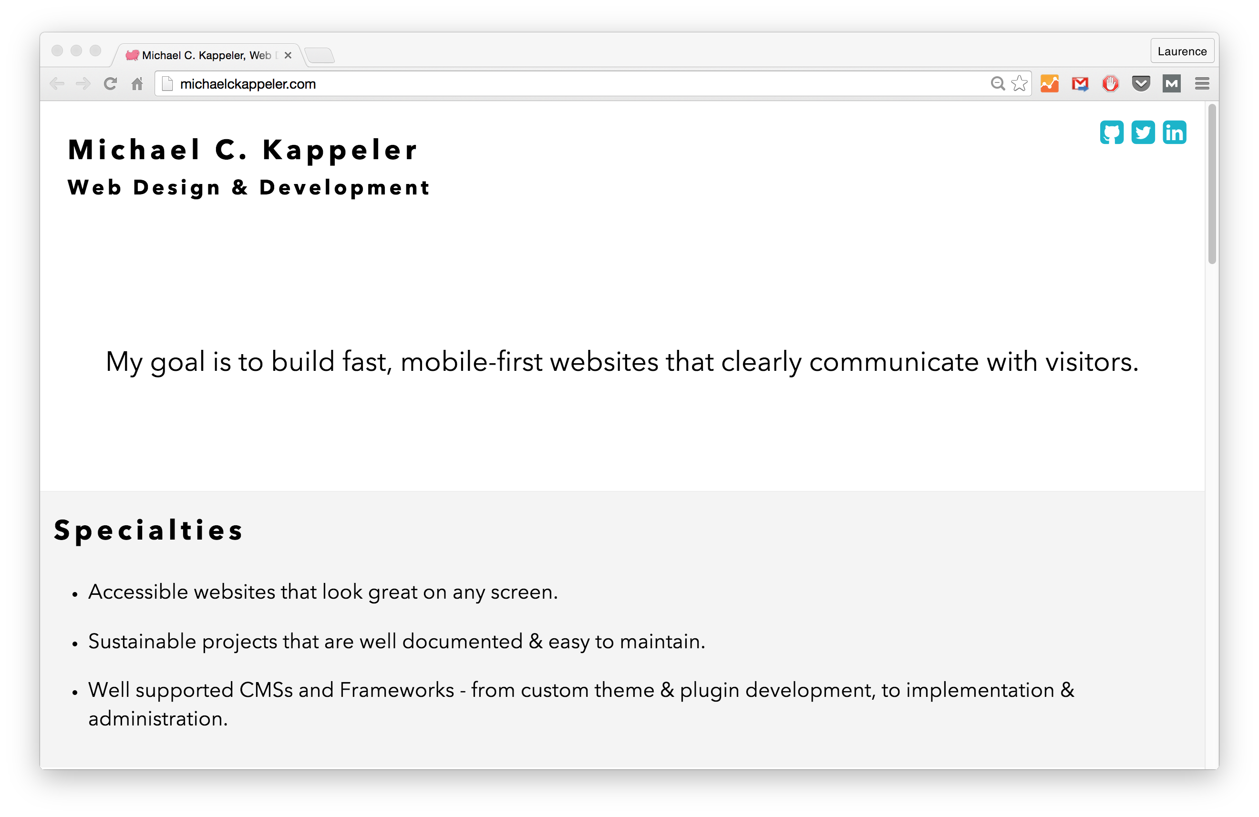Source: Michael C Kappeler

12. TESTIMONIALS
Including testimonials or reviews singing your praises is great for everyone, whether experienced or just starting out.
Of course, having testimonials from previous clients is best (extra bonus if they’re well-known). However, it could also be from friends/family you did work for.
It can be as simple as a quick blurb talking about your work ethic.

REAL-LIFE EXAMPLE:
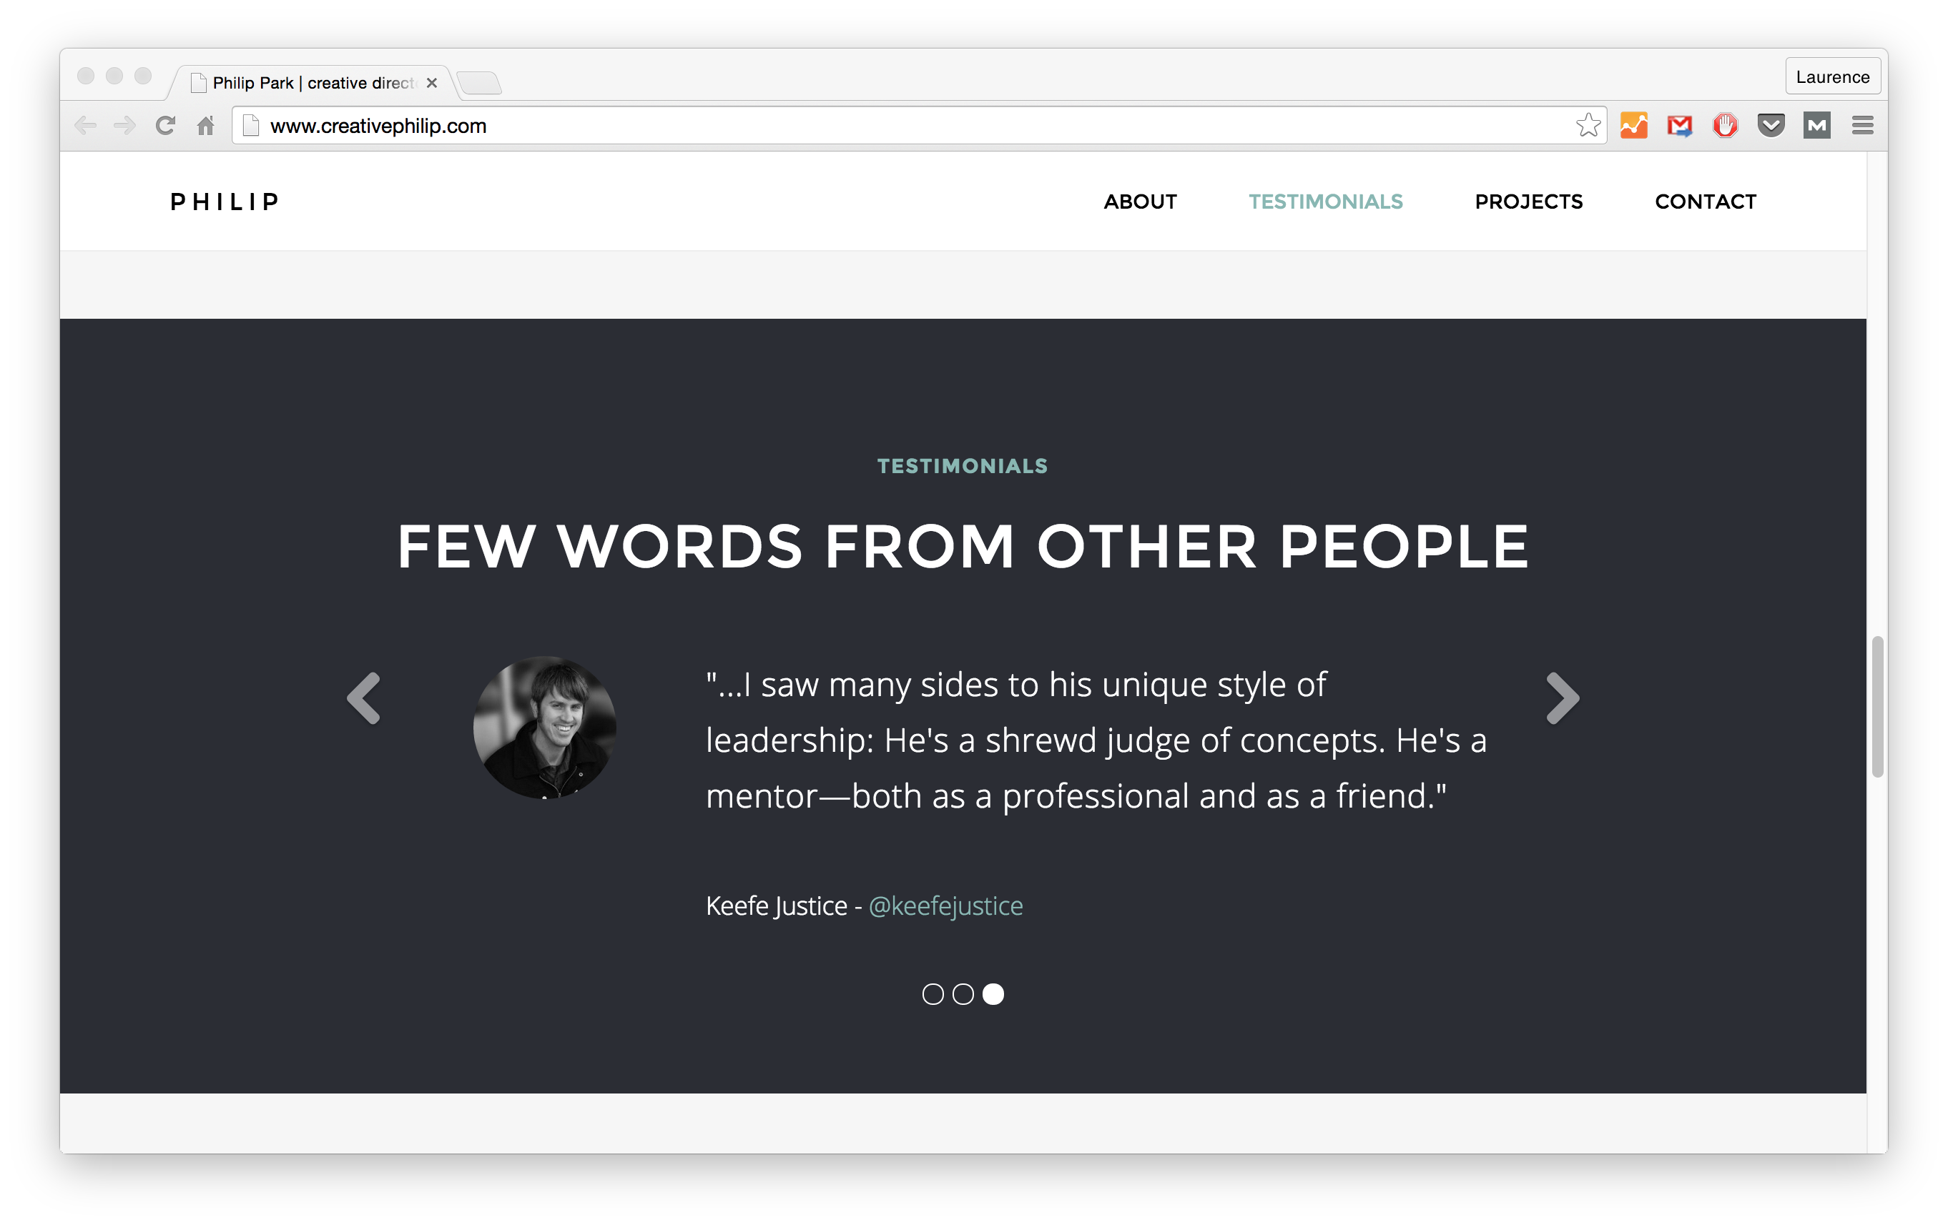Source: Philip Park

13. AWARDS/OTHER TYPES OF RECOGNITION
Have you ever been recognized for something outstanding—that is also relevant to your new dream field?
Maybe it was…
- winning a design contest
- placing in a hackathon or capture the flag competition
- receiving an award in your local area (or online)
If yes, add it to your portfolio and even LinkedIn! The example below includes awards, as well art exhibitions.

REAL-LIFE EXAMPLE:
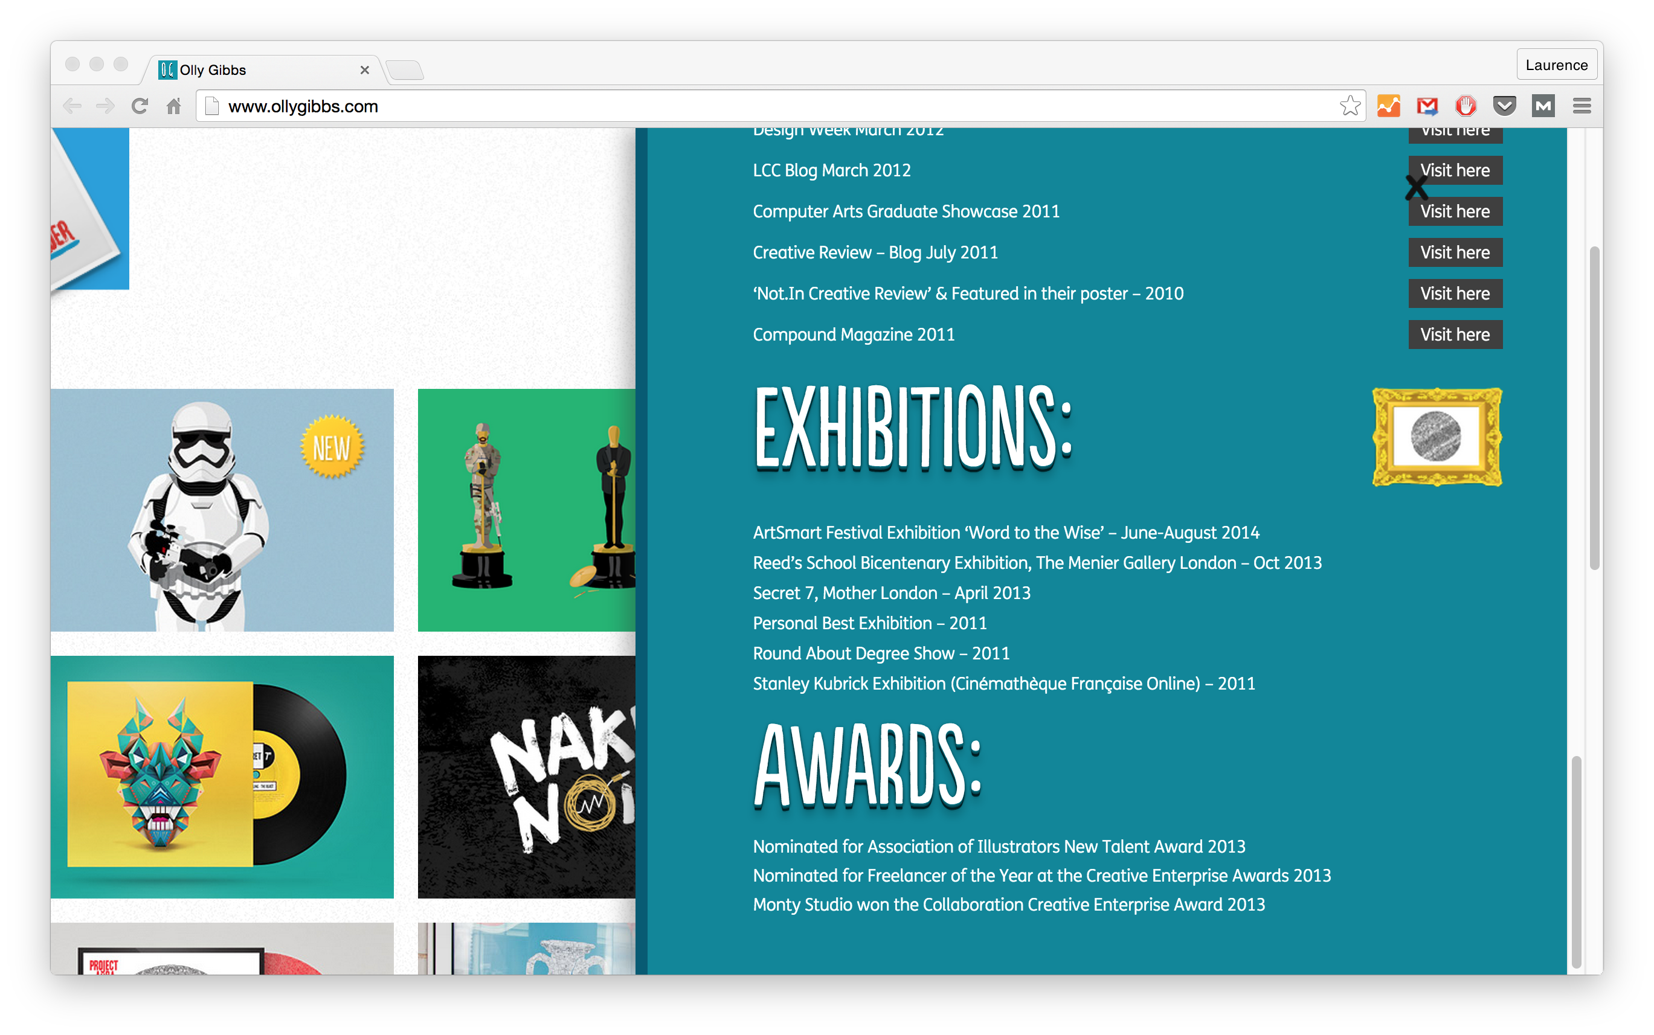Source: Olly Gibbs

14. A BLOG
It’s over-said, but blogging can bring about amazing opportunities. (If done correctly, of course.)
A blog could be included right on your online portfolio or resume, or you could write on an outside site, like Medium.
For instance, John Schnettgoecke wrote on Medium as he made his way through The Iron Yard coding bootcamp. (And it was awesome.)
When creating a blog, it is usually best practice to make it relevant to the projects/clients you want.
Consider:
- What type of stuff would they be reading?
- What do they want to hire for?
On the other hand, you can create a blog about something you’re passionate about (cooking, makeup, skiing, etc.) You can always then add it to your portfolio as a personal project—which we’ll be talking about soon.

REAL-LIFE EXAMPLE:
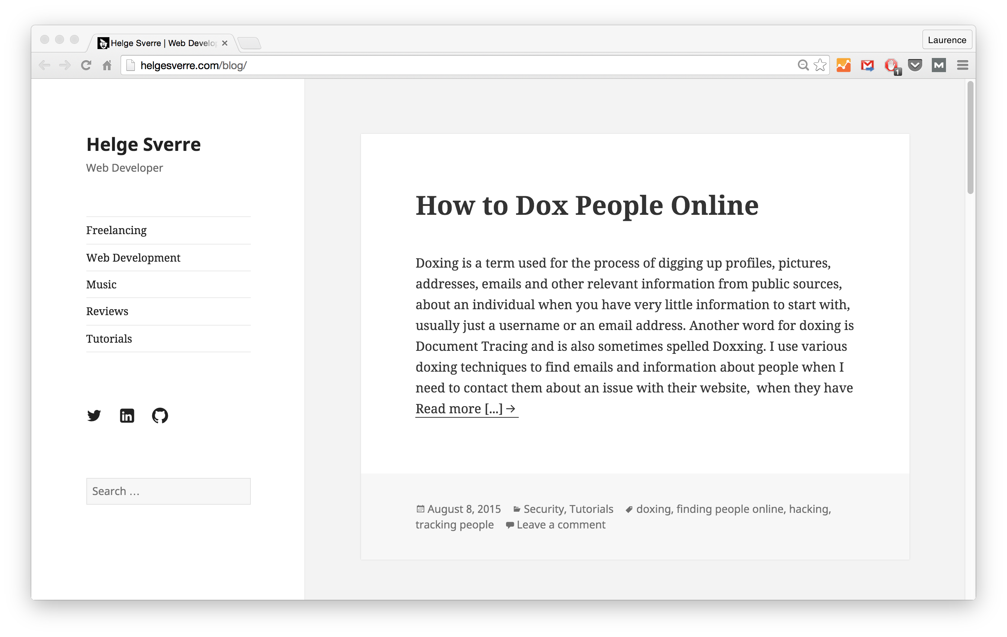Source: Helge Sverre

15. VIDEOS
Not much of a writer? Fear not. You can also gain exposure by creating helpful videos on the area you want to work in.
For instance, if you want to be a WP developer, make videos showing how to use plugins, or demonstrate other WP-related tips and tricks. Upload them to YouTube and/or Vimeo.
The example below shows Scott Tollinksi’s portfolio, who has the YouTube Channel LevelUpTuts.

REAL-LIFE EXAMPLE:
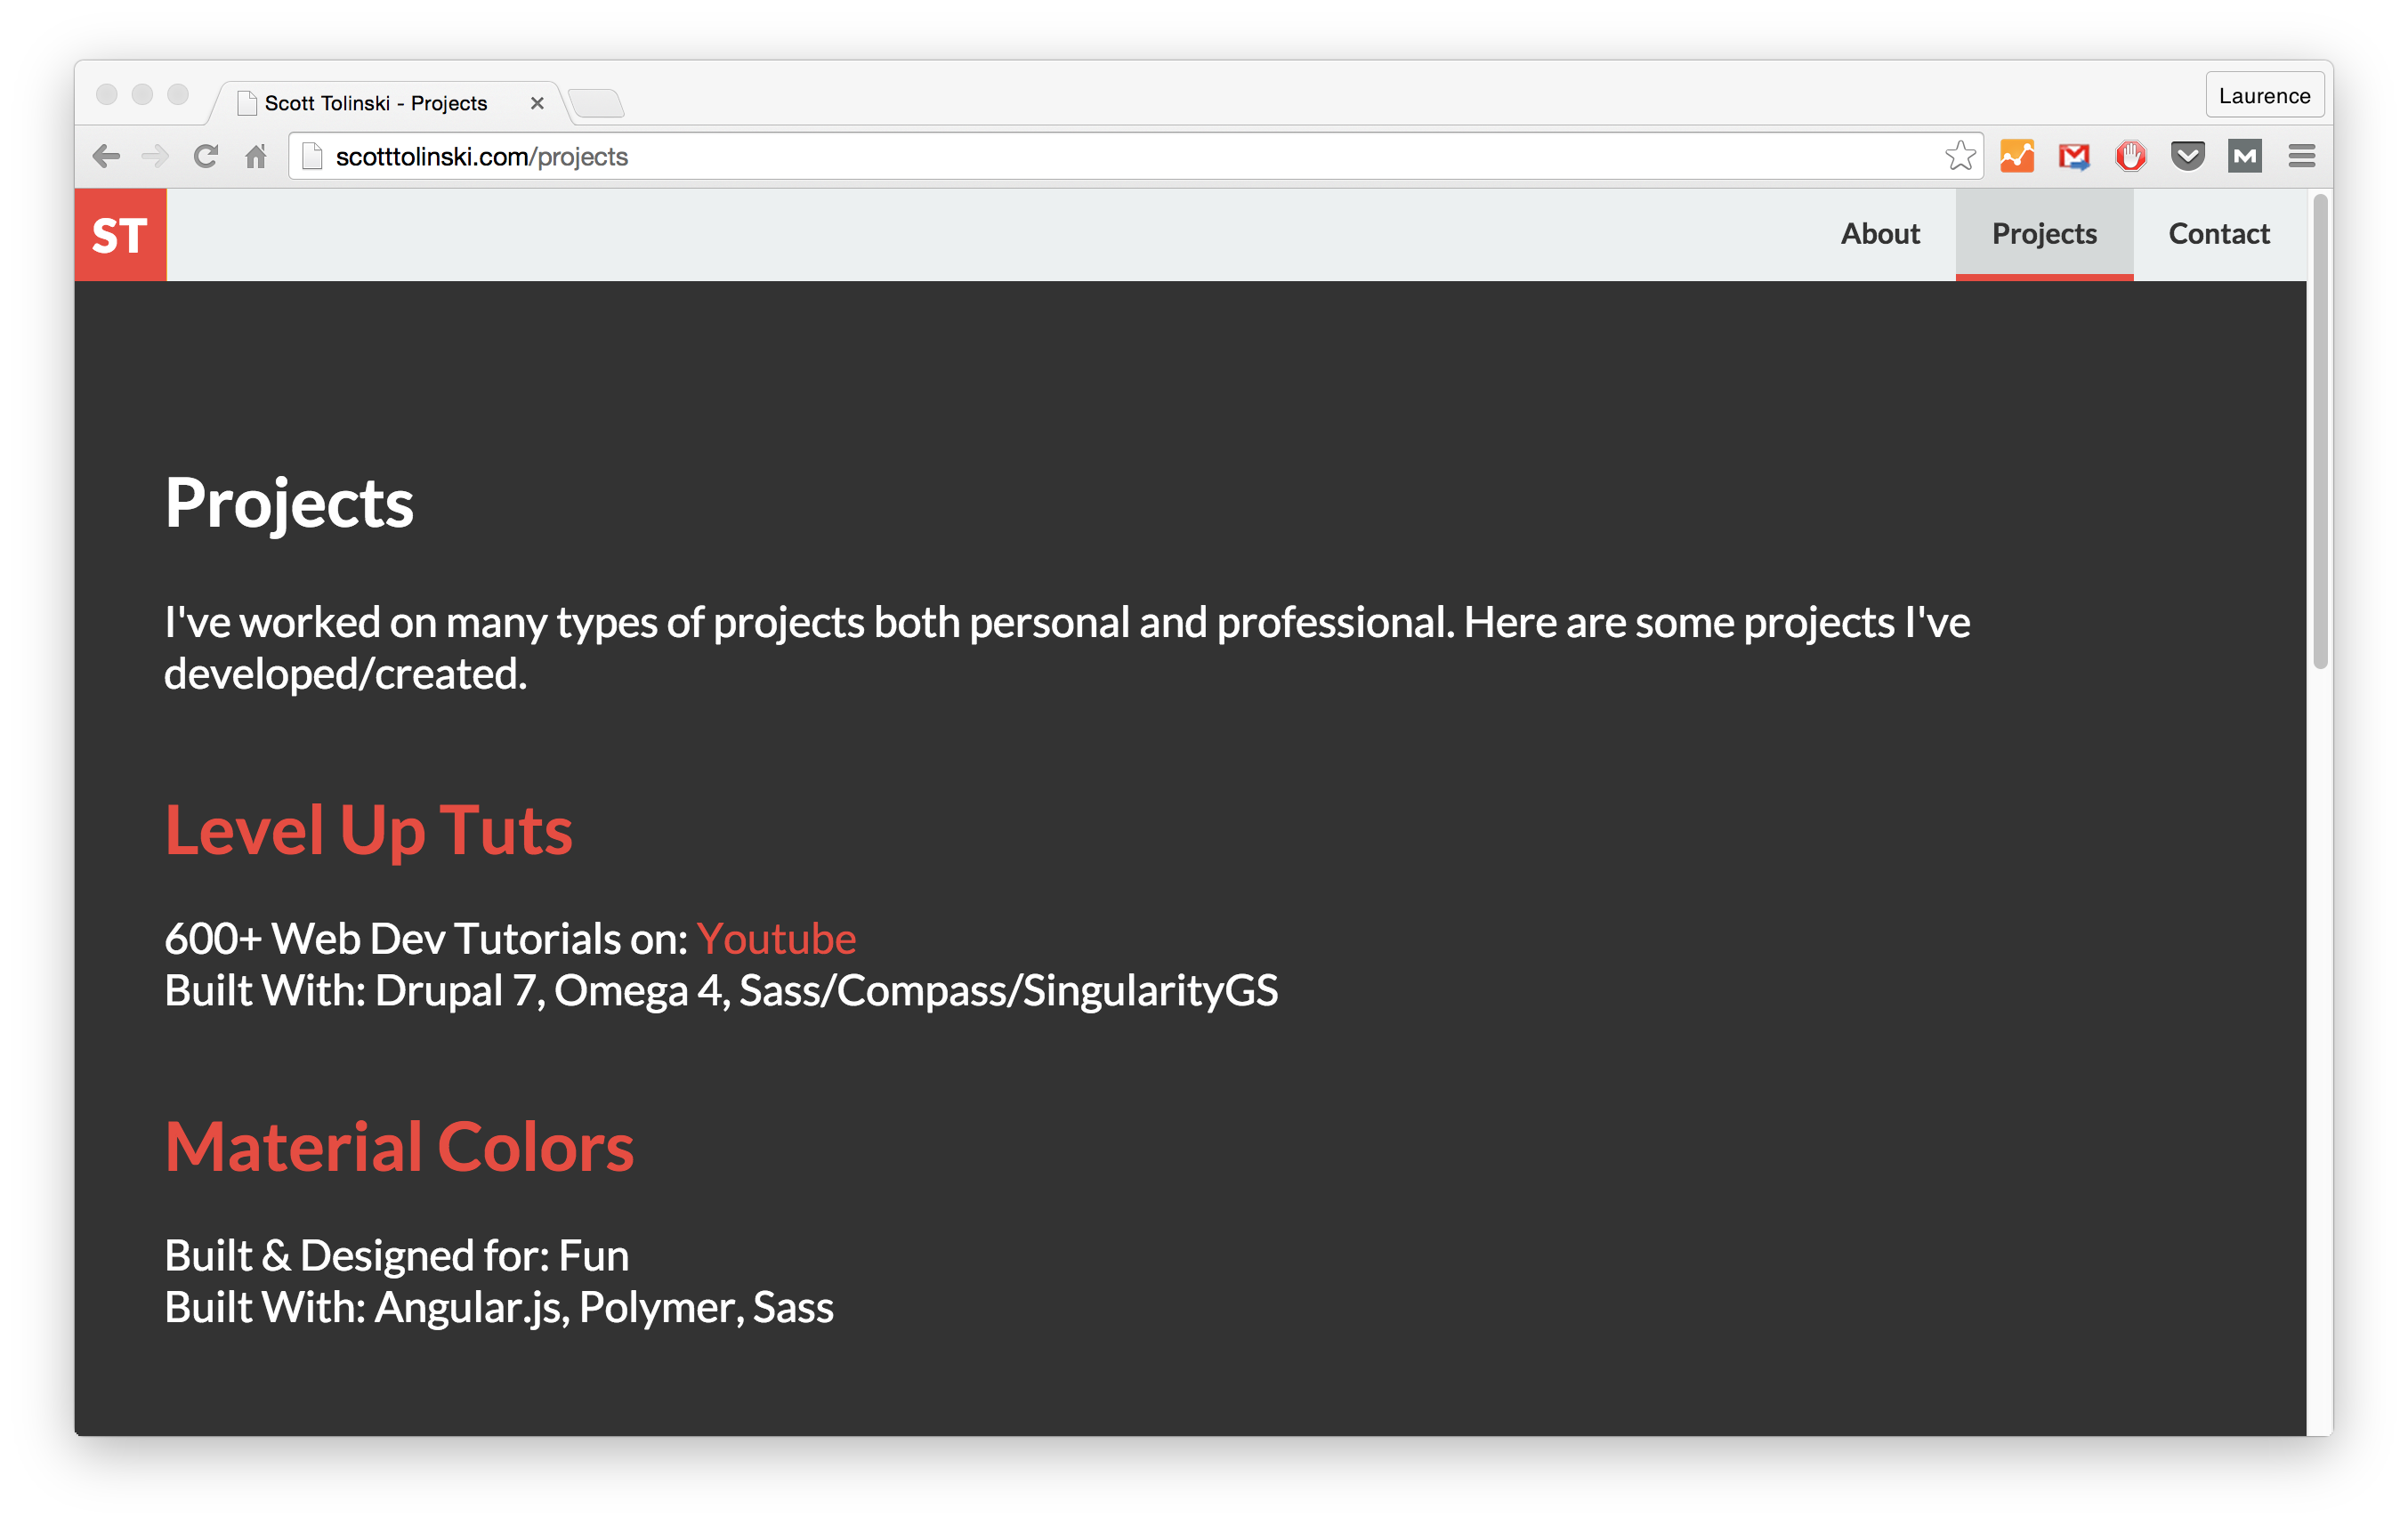Source: Scott Tolinski

16. YOUR OWN PROJECTS

JOIN THE FREE PORTFOLIO COURSE
Sign up below for my *free* course on how to build a portfolio site as a web developer/designer.
ENROLL NOW!Don't worry. I'll never, ever spam you!
Don’t hesitate to add your personal side projects—there are no rules saying you have to be paid for something for it to be legitimate!
You can even include small things, like a menu you built on Codepen.
Coursework you’ve completed could work well also, like a thesis, dissertation, or even one school project in particular. Say, for a business course, you made a website for the final project. As long as it demonstrates skill and helps support your goals, it can be added.

REAL-LIFE EXAMPLE:
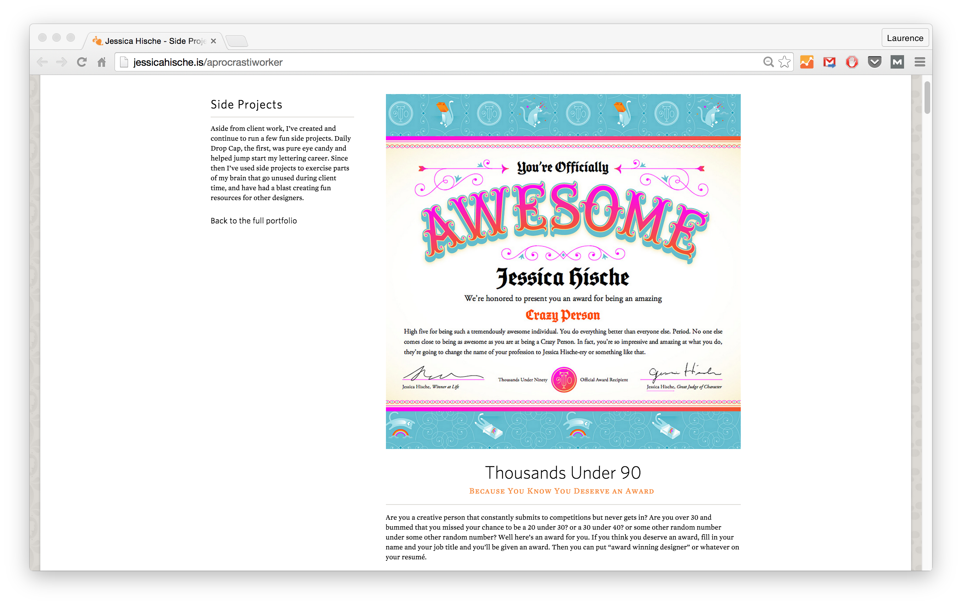Source: Jessica Hische

17. VOLUNTEER WORK
Volunteer your services to a non-profit you like. Or just help out a friend/family member in exchange for a glowing testimonial.
When first starting out, you may have to work for little or even free. And that’s okay—you gotta start somewhere. But make sure it is something you can add to your resume/portfolio.
Sometimes you have to work for little or free. Just make sure you can add to your portfolio.
CLICK TO TWEET

REAL-LIFE EXAMPLE:
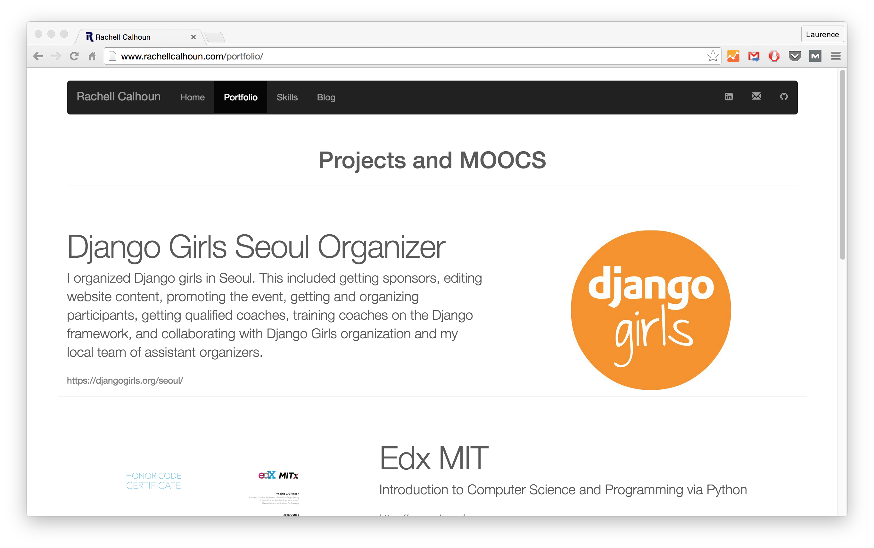Source: Rachell Calhoun

18. AN EXPLANATION OF YOUR PROCESS
Everyone has a different work style. Put some thought into understanding yours, then write up a step-by-step guide to that process.
You can go over things like the tools you use, your estimated turnaround time frames, etc. This will also help keep you and your client/employer on the same page without making them ask you a million questions.

REAL-LIFE EXAMPLE:
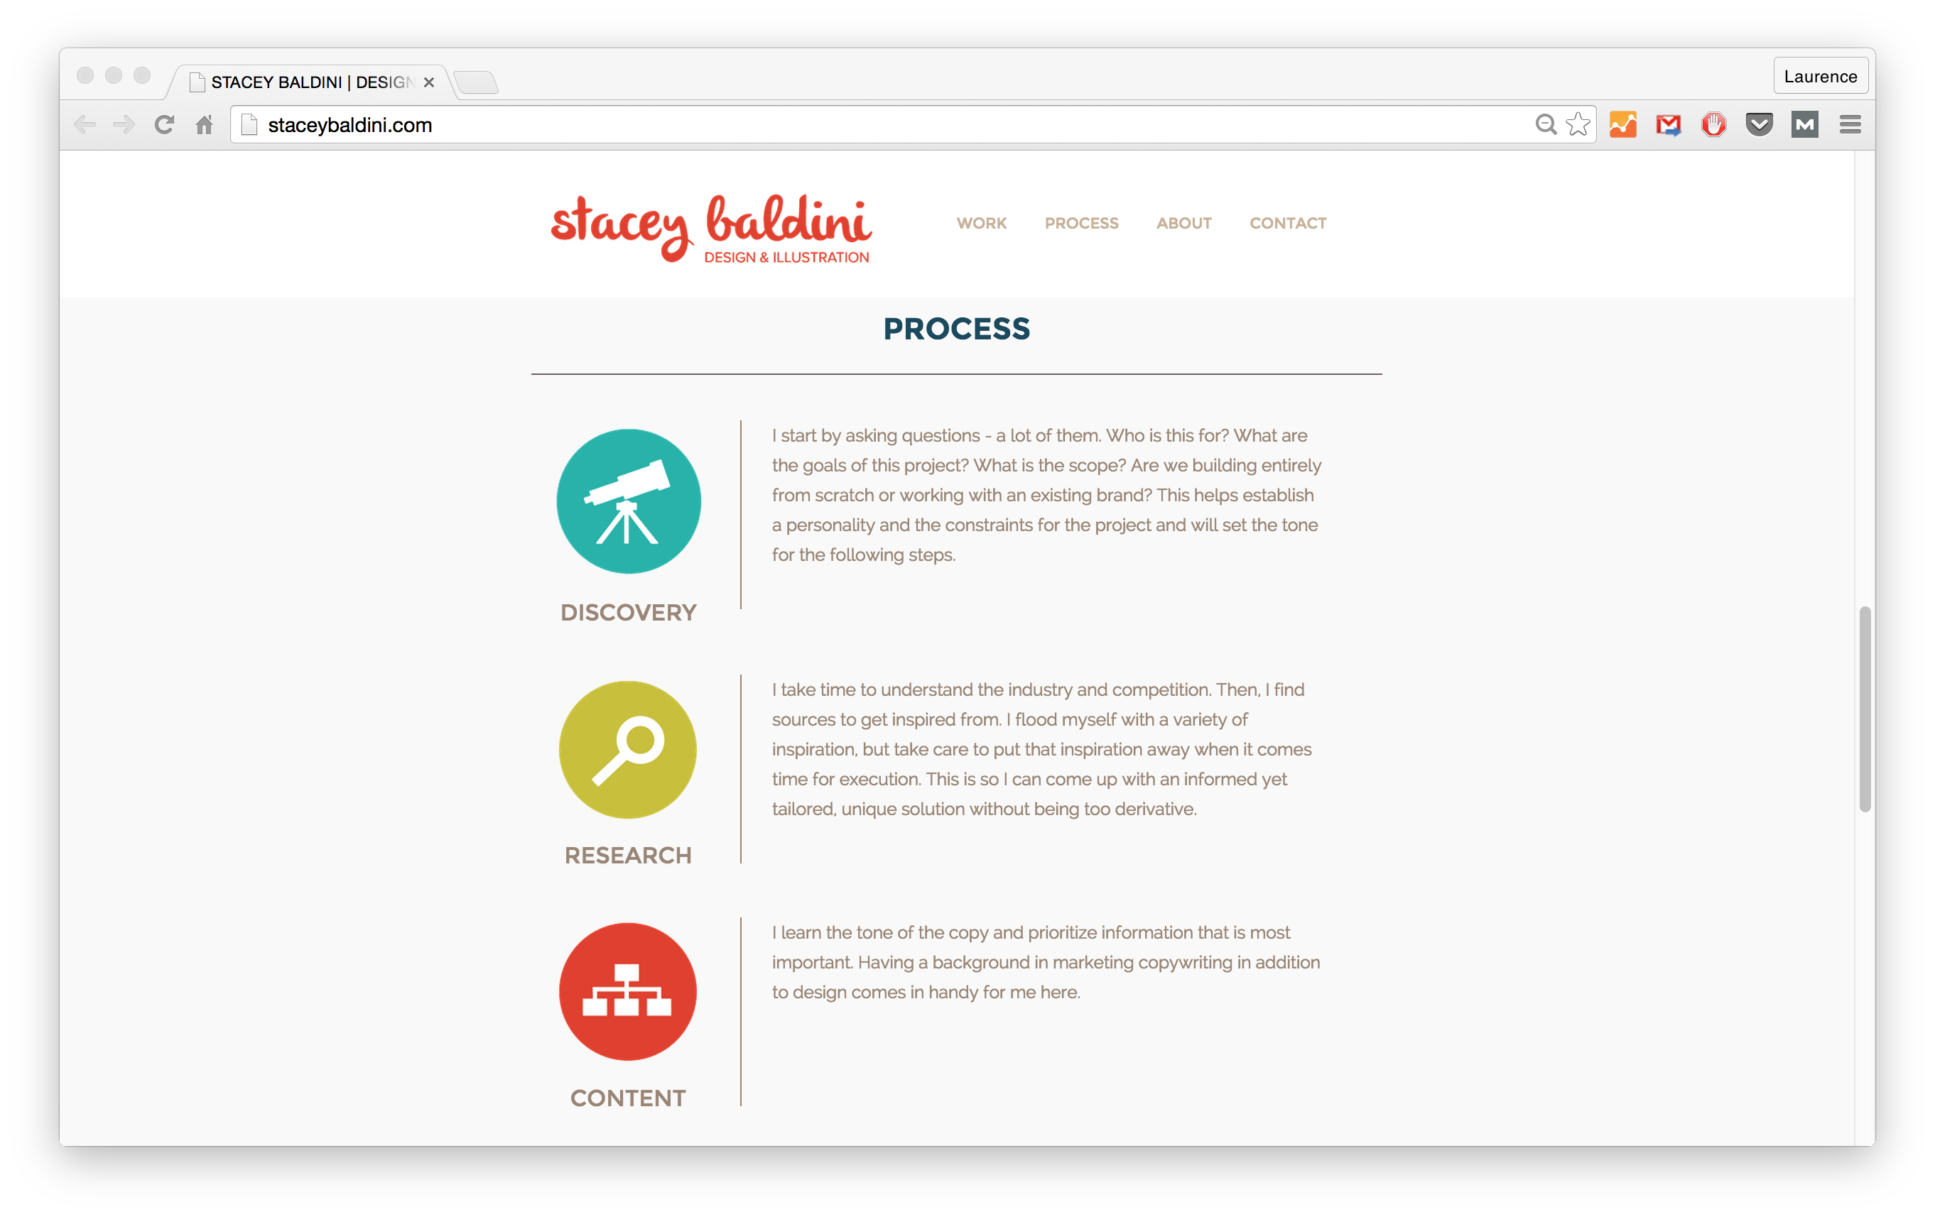Source: Stacey Baldini

19. OPEN SOURCE CONTRIBUTIONS
This is relevant for the web developers out there.
Contributing to open source projects not only shows initiative, but positions you as a team player and someone who’s not just in it for the money.
Plus, it’s yet another way to build more of that much-needed experience!

REAL-LIFE EXAMPLE:
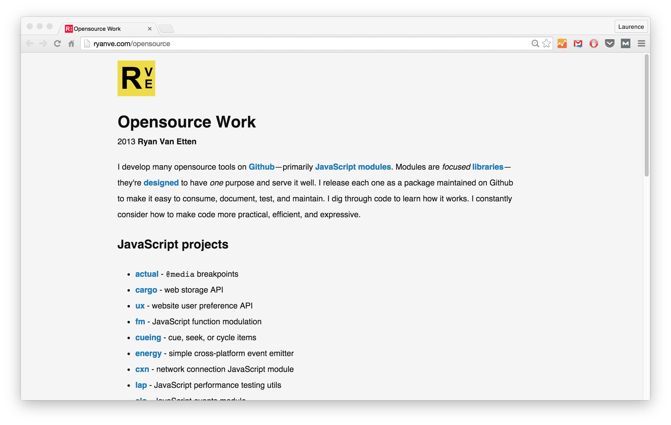Source: Ryan Van Etten

20. QUANTIFIABLE ACHIEVEMENTS
Quantifying is always good on any resume or portfolio.
This is even more important for freelancers/consultants and those just starting out, since it helps demonstrate your value in specific terms.
Portfolio pro tip: Quantify your experience b/c it demonstrates your value in specific terms.
CLICK TO TWEET
Examples could be:
- “My new homepage design helped increase time on page by one minute.”
- “Landing page redesign dropped bounce rates by 15%.”
- “New blog layout increased pages per session by 20%.”
There are different ways you can do this. The important thing is quantifying and showing results.
Below, Wells does this by mentioning the number of students and readers under “Notable Achievements”.

REAL-LIFE EXAMPLE:
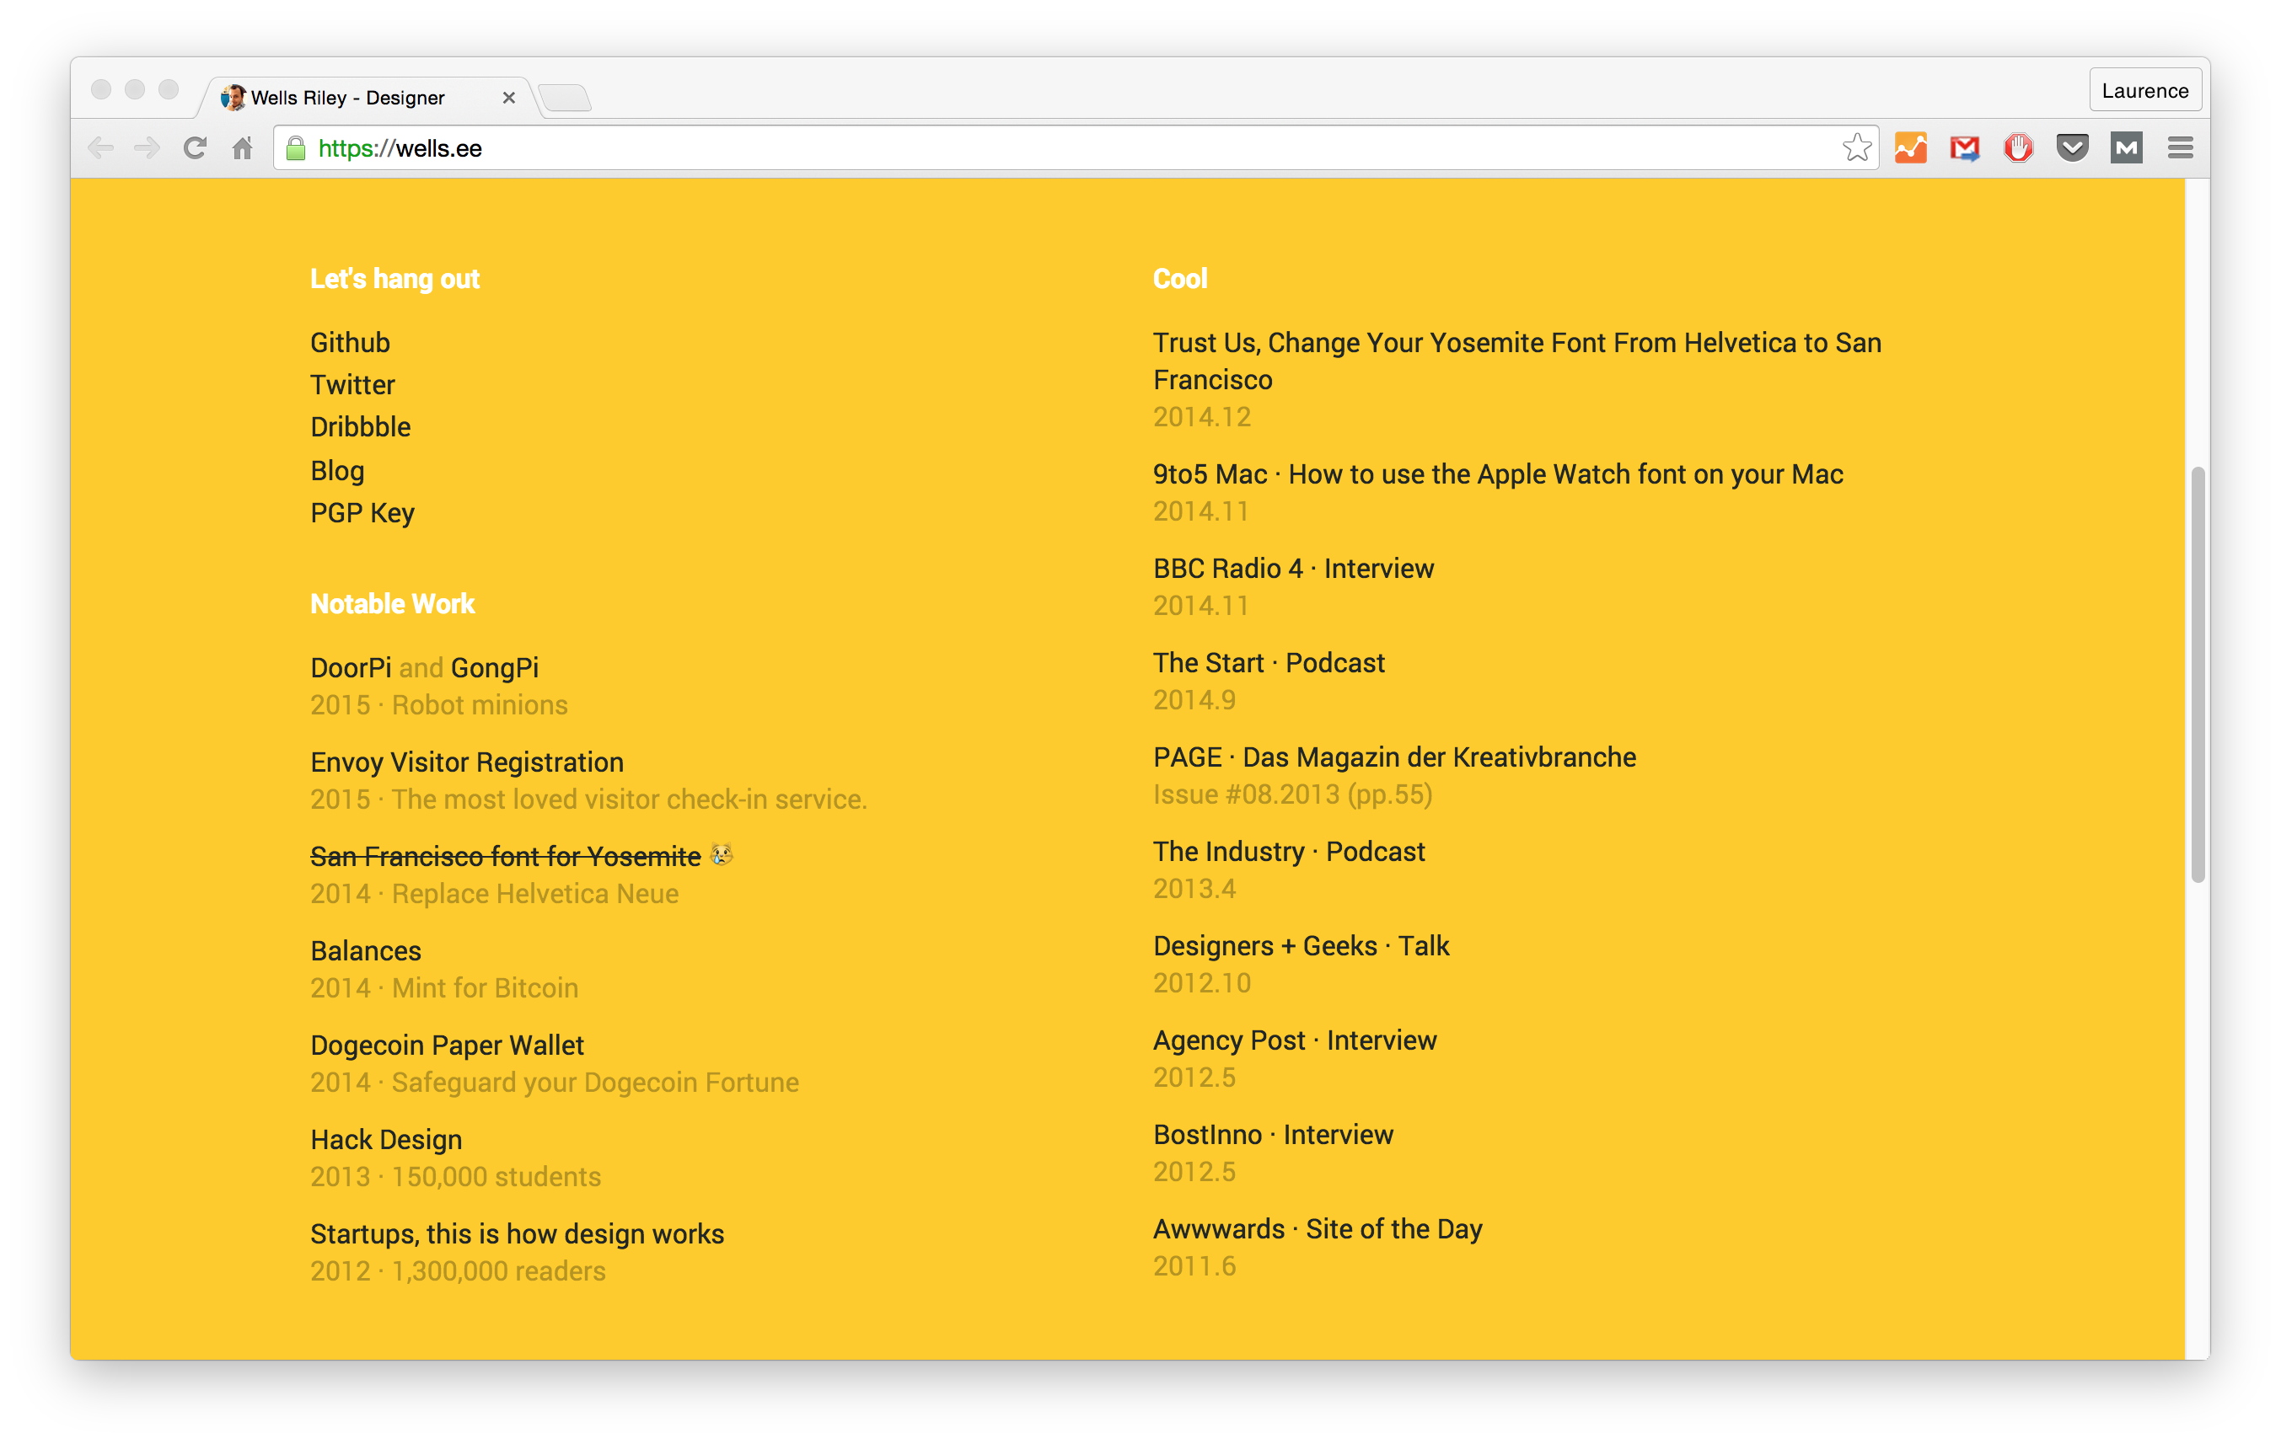Source: Wells Riley

21. RELEVANT GROUPS/COMMUNITIES YOU’VE HELD A LEADERSHIP ROLE IN
Starting or participating in a group (online or offline) can show leadership and initiative.
Examples of online groups could be:
- A FB group for web devs
- Starting a forum on Mightybell (or on your own, like Crater.io)
Examples of in-person groups:
- A meetup group in your area
- A chapter of an existing national group like Girls Who Code or TechGirlz
Taking on leadership roles in these groups is not only something to add to your portfolio. It also gives you the opportunity to network and make connections in your industry.

REAL-LIFE EXAMPLE:
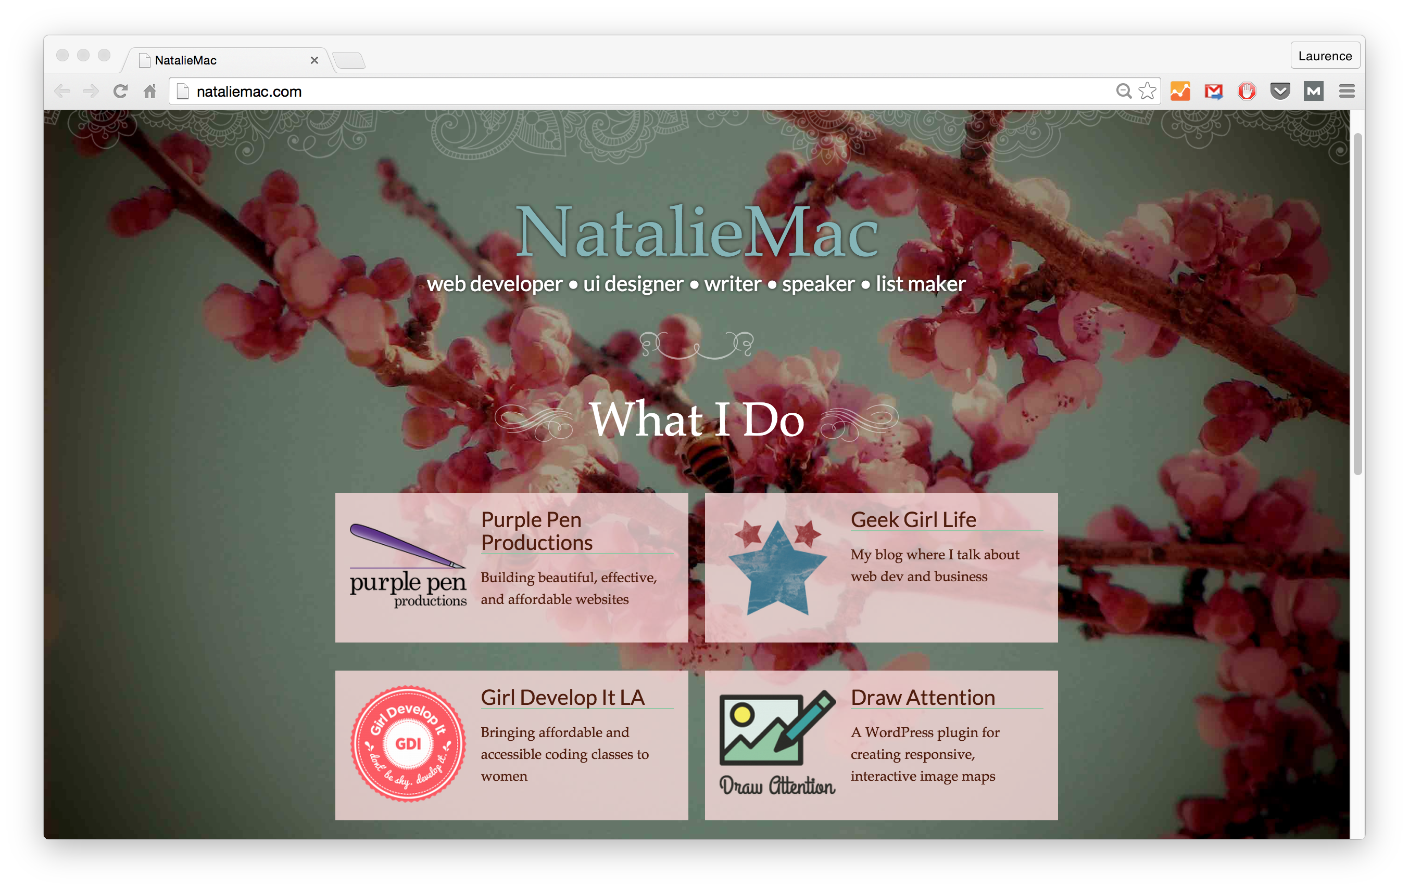Source: Natalie MacLees

22. SPEAKING ENGAGEMENTS
Again, as long as these speaking engagements are relevant. It’s a point that’s worth repeating!
Similar to above, this could be online or offline, since nowadays there are online conferences or virtual summits.

REAL LIFE EXAMPLE:
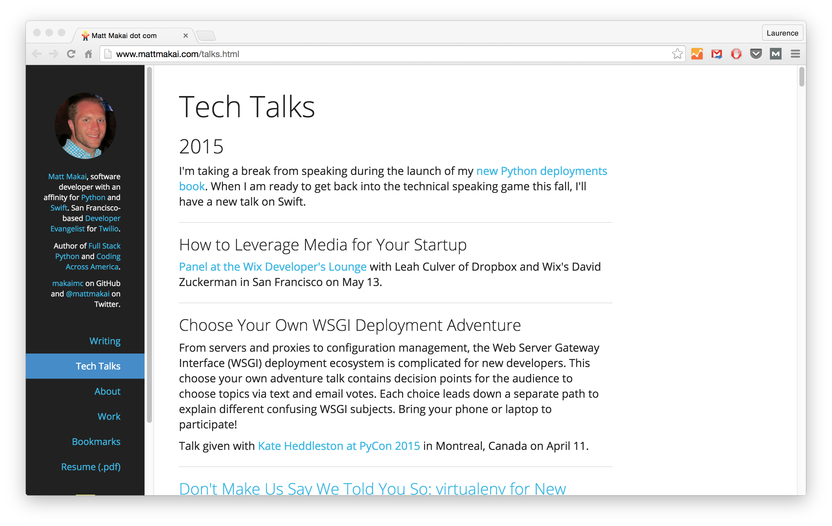Source: Matt Makai

23. LINKS TO GUEST WRITING OR FEATURES

JOIN THE FREE PORTFOLIO COURSE
Sign up below for my *free* course on how to build a portfolio site as a web developer/designer.
ENROLL NOW!Don't worry. I'll never, ever spam you!
What better way to show off your expertise and gain exposure? And then you can add those articles to your portfolio!
It can be guest writing or appearances you have made—big or small. (Hey, everyone’s gotta start somewhere! You can’t just wake up and be featured in Smashing Magazine or A List Apart.)
In fact, it doesn’t even have to be writing. It could be illustrations or infographics.

REAL-LIFE EXAMPLE:
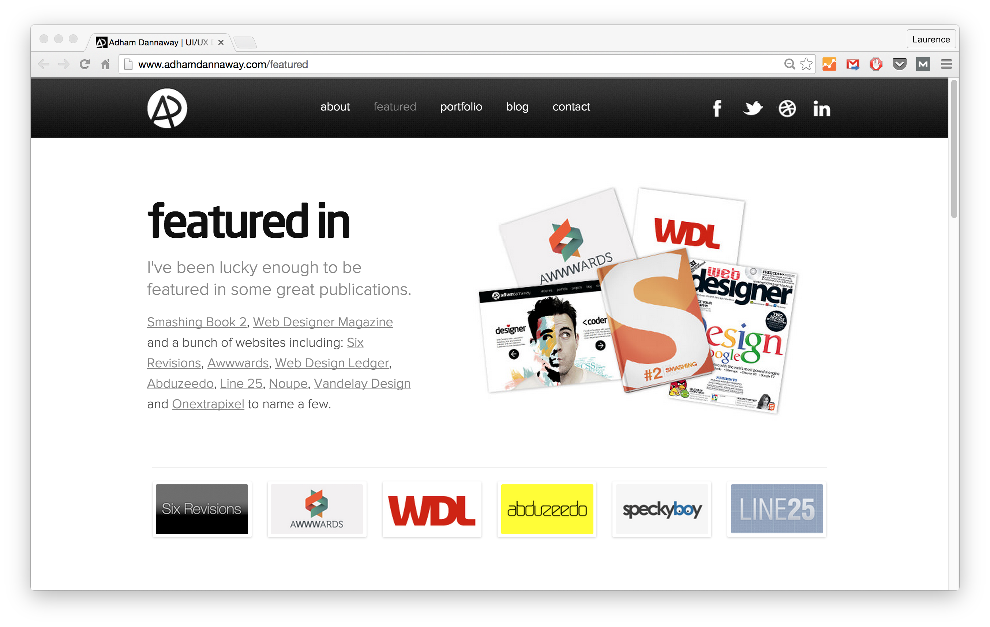Source: Adham Dannaway

24. A BLOG THEME FOR OTHERS TO USE
A great way to showcase your skills and help others at the same time is to create a free theme/template—like a WordPress theme.
Then, add it to your portfolio.
Think it’s really awesome? Consider selling it!
Again, creating a theme is a way to demonstrate your capabilities, while making something useful that can help others.

REAL-LIFE EXAMPLE:
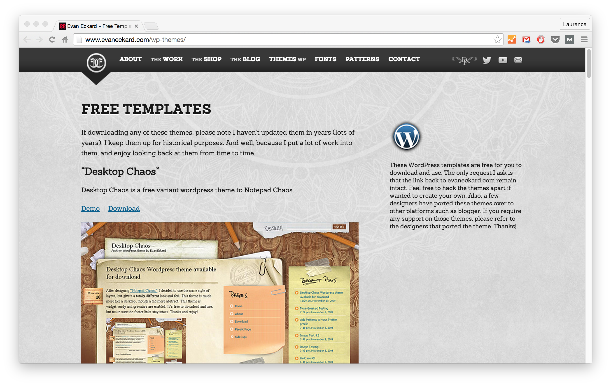Source: Evan Eckard
Unsure of what to include on your dev/design portfolio? Here are 27 ideas.
CLICK TO TWEET

25. YOUR OWN ICON SETS/PATTERNS/FONTS
Creating an icon set or related is an option more geared towards designers. In fact, these kinds of free icons/patterns are almost like work samples.
Allow people to use them for free. In exchange, request people to link back to your site and give appropriate credit to you. (Which is a backlink—meaning it’s great for boosting your website traffic and getting more exposure.)

REAL-LIFE EXAMPLE:
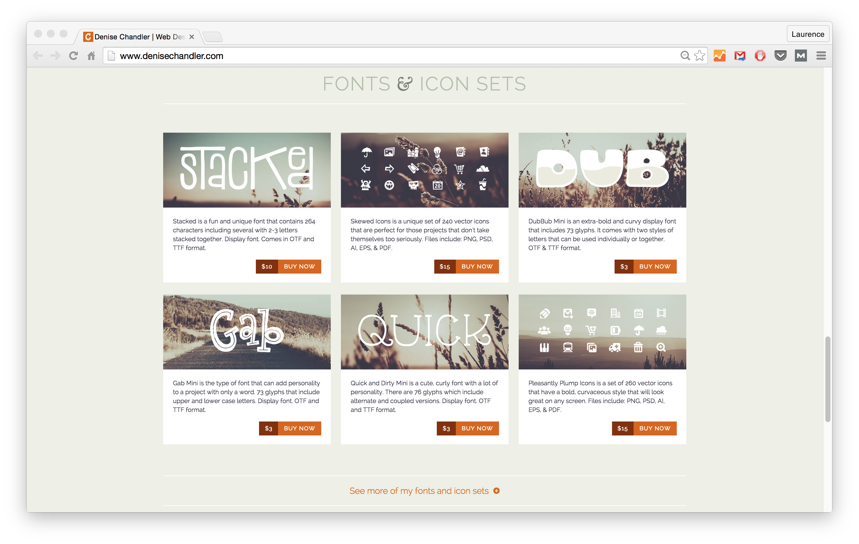Source: Denise Chandler

26. FREE CHEAT-SHEETS/GUIDES/TUTORIALS
A great way to gain exposure and attract attention is by sharing what you know.
One way to do this is by creating free cheat-sheets or guides, and make them available on your site for download.
Portfolio pro tip: gain exposure by sharing what you know in guides or cheat-sheets.
CLICK TO TWEET
Here's two examples:
- If you’re an aspiring Ruby on Rails developer, you could create a guide to installing Rails.
- If you’re an aspiring UX designer, you could create a free checklist to help people make sure their site is optimized for users.
Below, Wes Bos has an entire section on his website dedicated to tutorials.

REAL-LIFE EXAMPLE:
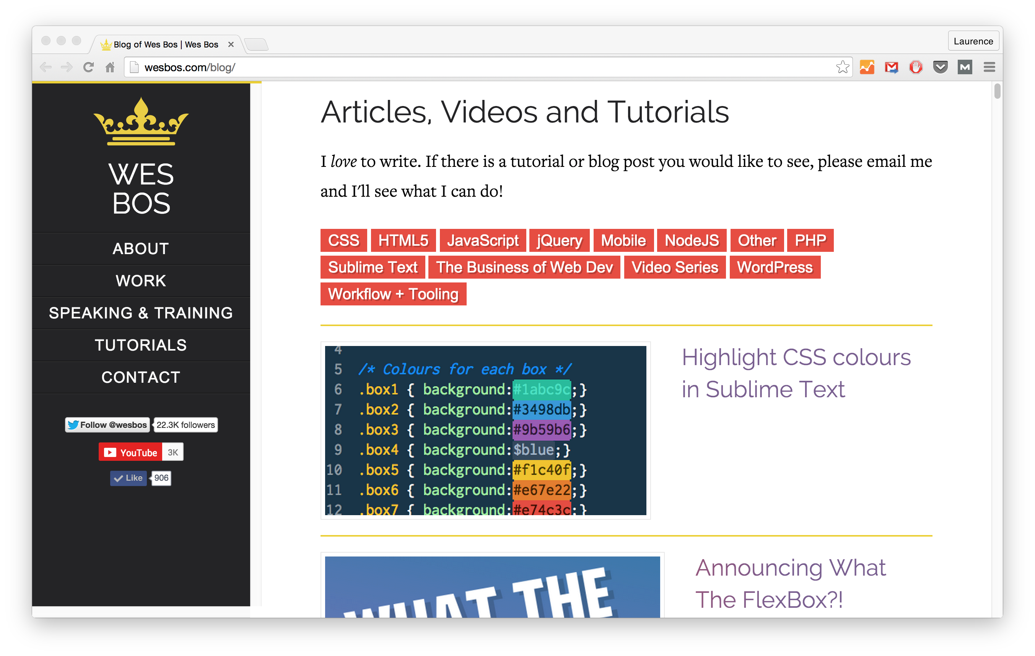Source: Wes Bos

27. CALL TO ACTION (CTA)
What is the main goal of your portfolio? It could be:
- To get new clients
- To land a full-time job
- To collaborate with cool people on new projects (or your own business)
Emphasize that goal through your CTA.
Pages should have a CTA that gives site viewers a viable next step to take. Maybe it’s “get a quote” or “view resume” or even “hire me”.
The below example has two buttons. One links to a form for people who need a website, and the other to his resume, where recruiters/hiring managers can see his experience and skills.

REAL-LIFE EXAMPLE:
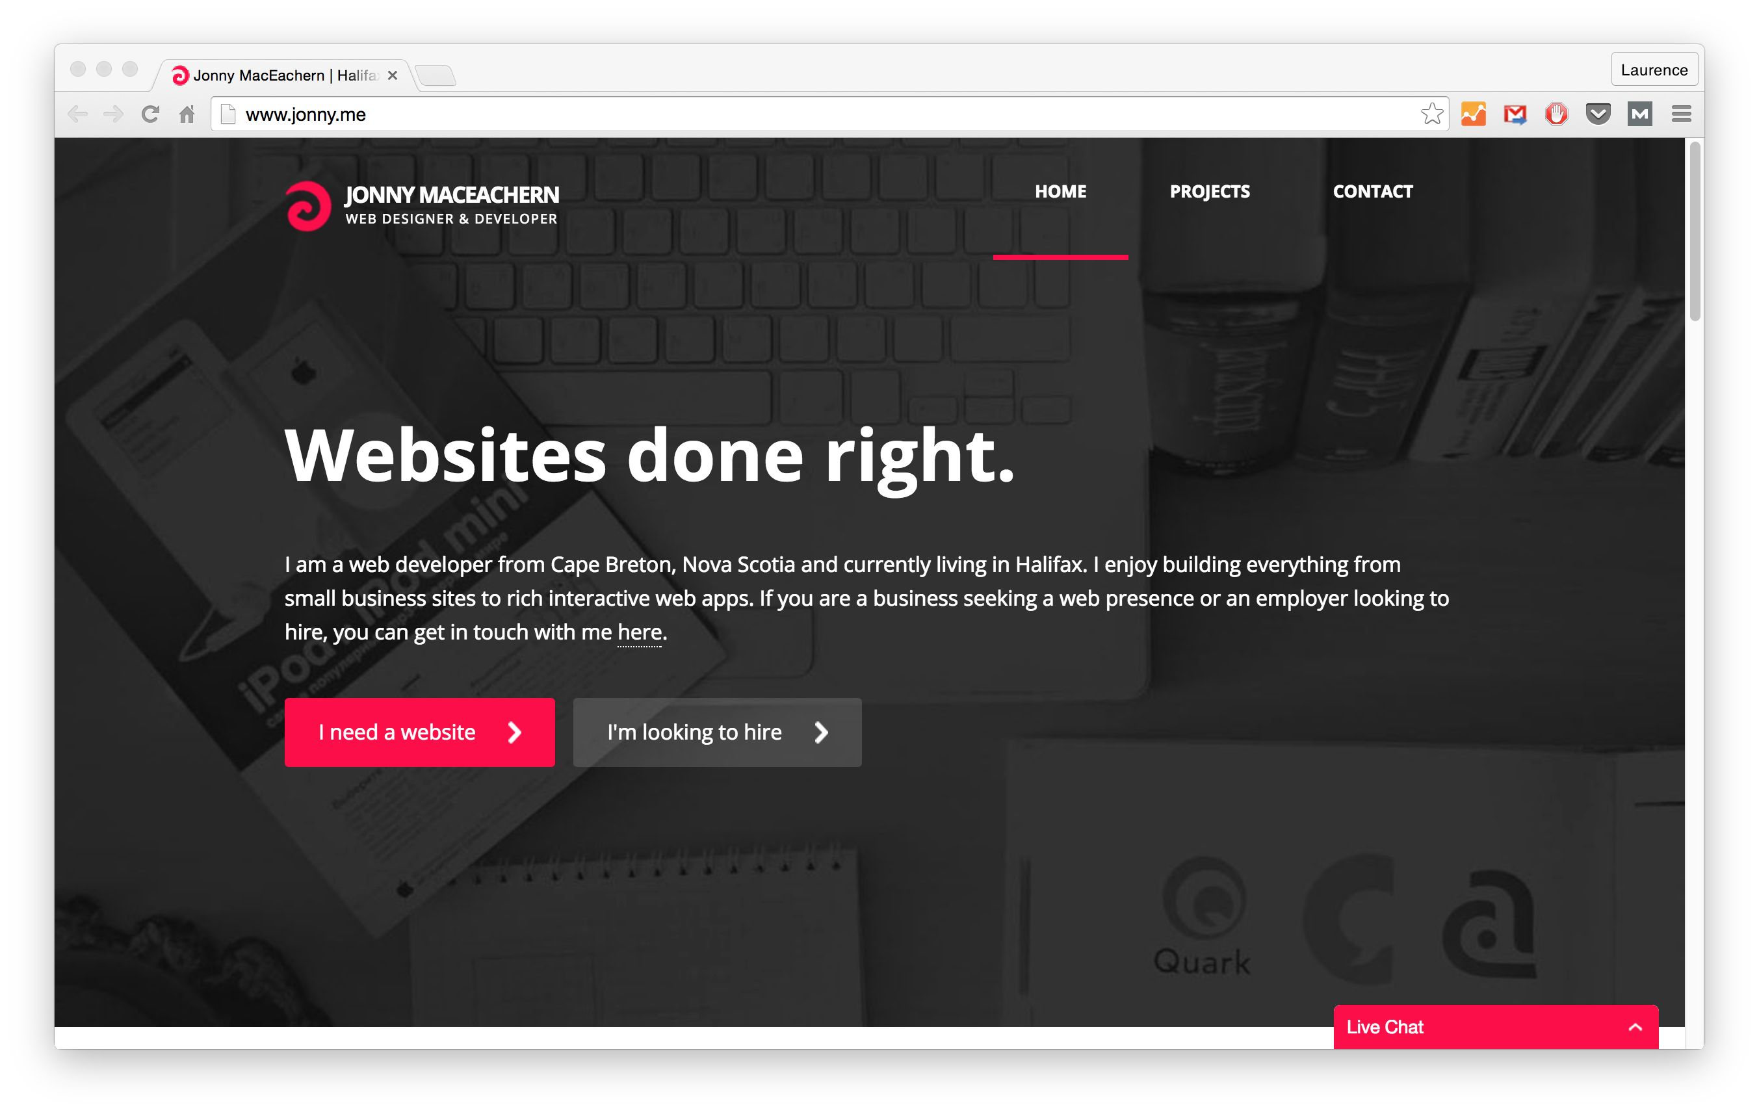Source: Jonny MacEachern

I'VE GOT ONE QUESTION FOR YOU…
Are you ready to start making your portfolio?
Then you definitely need to head over to portfoliodojo.com, where you can learn more about my course on how to make a portfolio as a dev/designer.
It contains a TON of information that'll help you get started. Because it's time to make a portfolio you're proud of :)

